**Course Code: EIE4432**

**Course Name: WEB SYSTEM AND TECHNOLOGIES**

**Student Name: HUANG ChengXi**

**Student ID: 19079312D**

**Assignment Name: Web Project**

**Date: December 5, 2021**

Contents

Introduction 4

Methodology 4

1. Schedule 4

2. Database Structure 5

1). users 5

2). Item 5

3). Cart 6

4). Buyerinfo 6

3. Database ER Diagram 7

4. Detail introduction of Login System 7

5. Sign up and Forget password 9

6. Userhome (customer purchasing) 14

7. Shopping Cart (optional function) and buying 17

8. Userpage (extra function for modify user info and see purchase history) 19

9. Admin Page (with optional function of showing the chart) 22

10. Logout 29

11. CSS 29

Function List 34

1. Customer Registration 34

2. User login (logout, with cookies and sessions, reset password ) 35

3. Customer purchase clothed 36

User Page 36

Brows all kinds of clothes 36

Categories (Male, Female) 36

Shopping cart with Buying check 37

Purchase History 37

4. Shop keeper page 38

Check item (Modify stock, price, picture. Delete item) 38

Add new item 38

View records (Order by nickname, search ID) 39

Chart 39

Conclusion 40

Future Development 40

# Introduction

In this project, I use all of the knowledge that has been taught in class to build an inventory management system, which allows me sell and buy clothes on it. Moreover, it has different access for shop keeper and customers. For customers, the website will set the cookie of the user ID so that they do not have to login again after accidently closing the webpage. And the data of ID is transferred between pages as a session. Moreover, customers can add items in their cart, and purchase all the item in their cart. For shop keeper, the system can show the purchase record of all customers and can search certain record based on user ID. At the same time, shop keeper can see the top 3 best-sell cloth in a chart. Shop keeper also has access to modify the database like adding items, editing items, or deleting items.

In this project, I use lots of techniques to realize the functions and make the UI beautiful. The techniques include JSON, database management, CSS modifier and so on. The detail will be shown in the methodology part.

# Methodology

## Schedule

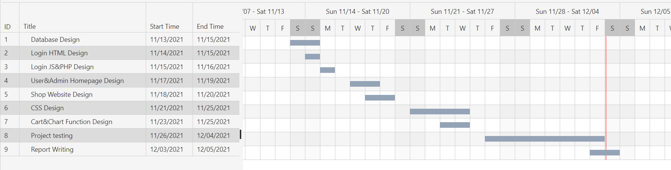This project is divided into seven parts: 1. Database Design 2. Login System design 3. Shop page Design 4. Cart And Purchase Record Function Design. 5. CSS Modify 6. Bug testing 7. Report Writing. And the schedule of each part are as follows:

## Database Structure

There are four designed tables in my database. They are 1. users 2. item 3. cart and 4. buyerinfo. And the details will be shown below:

### users

This table has 8 columns which are userid(PK), nickname, email, profile, gender birthday, type are password. The data type of profile is longblob which is used to store the 64byte transformed picture data and the data type of birthday is date(xxxx-xx-xx) while other data types are all varchars. In this case, I don’t need to save the picture I need in the file. I can upload all of them to the database.

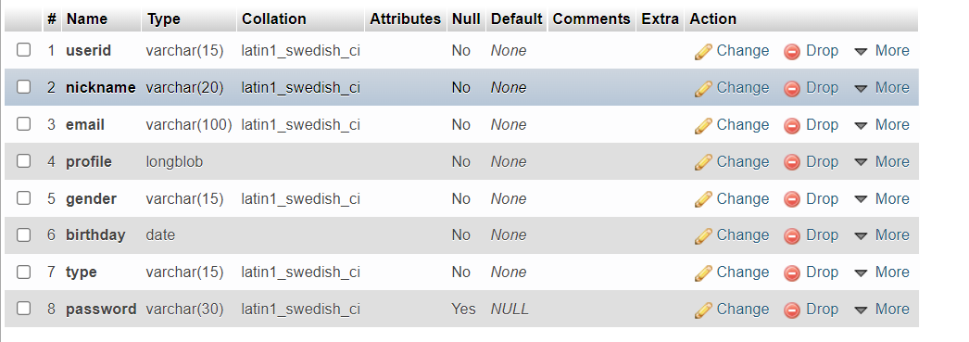A unique userid of each user are stored in userid, and the password is used to login. Users can choose to upload all the other information if they like including profiles.

### Item

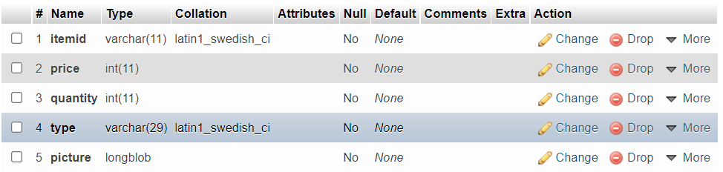This table includes 5 columns: itemid(PK), price, quantity, type, and picture. Itemid is a unique ID (varchar type) for each item, and the price and quantity (int type) are determined by shop keeper. There is also a type (varchar type) column in this table to distinguish it is a male cloth or female cloth which will be used in the category part.

### Cart

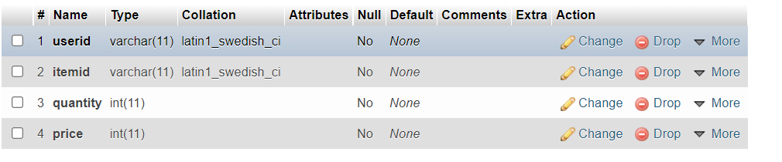Cart is an advanced function for this website, and *cart* table is implemented to realize this function. In *cart* table, there are 4 columns. *Userid* and *itemid* are two Foreign Key from table *users* and *item*. *Quantity* and *price* stored the buying quantity of item and the price of the item. To be noticed, the cart stored the information of all customers’ cart. And when the customers actually buy the items, they will be removed from the cart.

### Buyerinfo

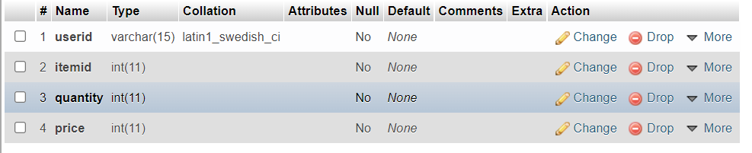*Buyerinfo* has same columns as cart. However, the *price* in *buyerinfo* stands for total price which is the multiple of item price and quantity. Users can check purchase history through this table and shop keepers can get the records of all users. Moreover, it can be used to build up a bar chart for shop keeper to clearly know about the most famous items.

The database is built up in phpMyAdmin and all the tables and columns are added through it. It has a powerful function to modify the database without writing some long codes. However, the query from the website need to use SQL language and must be written in php files.

## Database ER Diagram

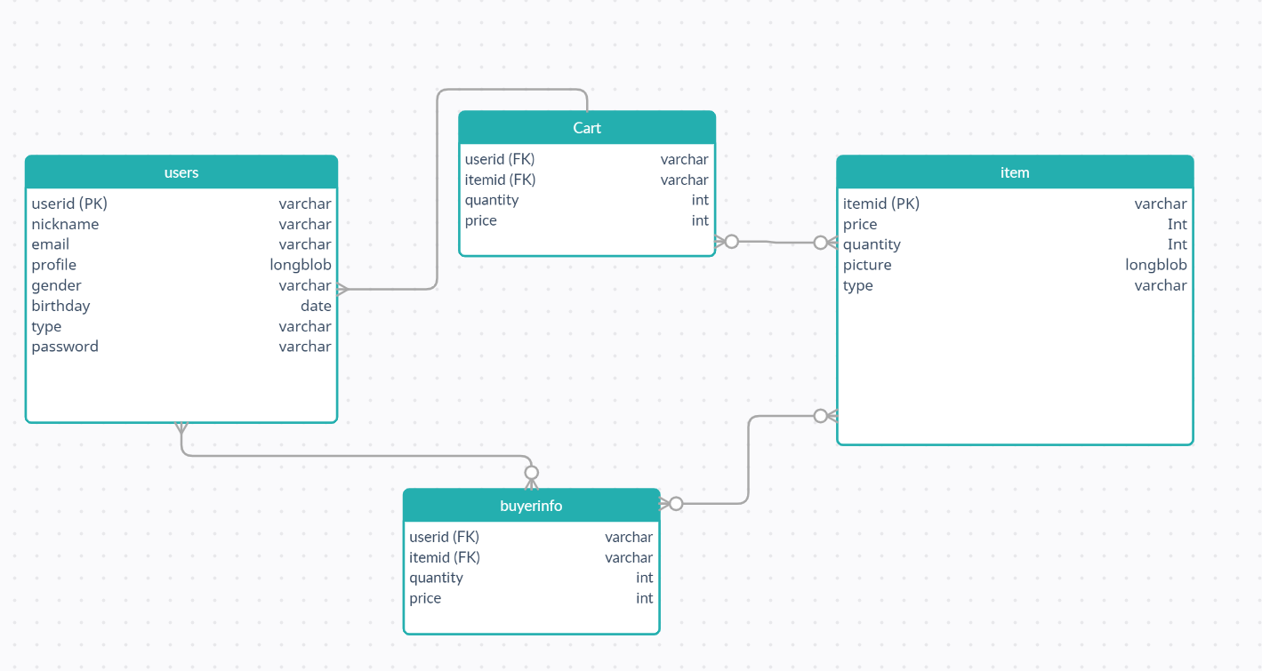

## 图片包含 网站 描述已自动生成Detail introduction of Login System

I use a php page as my login page, and there is a table for users to input userid and password. Moreover, a select bar is used to define the login type. Below the table, there is a submit button and two hyperlinks. The first link will lead to *sign up* page and the second link will lead to *reset password* page. Before loading this page, I check the cookies first. If there are cookie of userid exist, I just use this userid and head to *userhome* page.

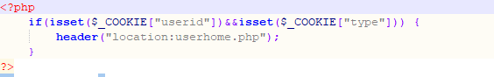

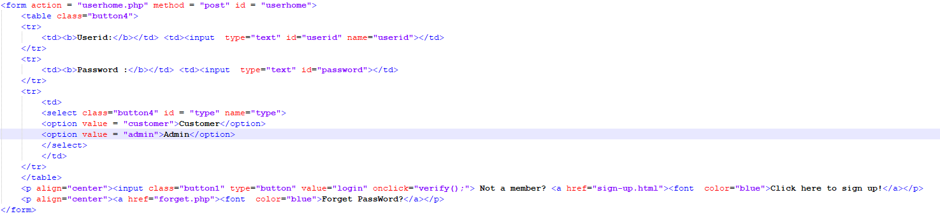

When the user presses the login button, it will call *verify()* function in the *login.js* to check if they are valid inputs. If it is a valid input, the JavaScript file will send the information of users to a php file using JSON format.

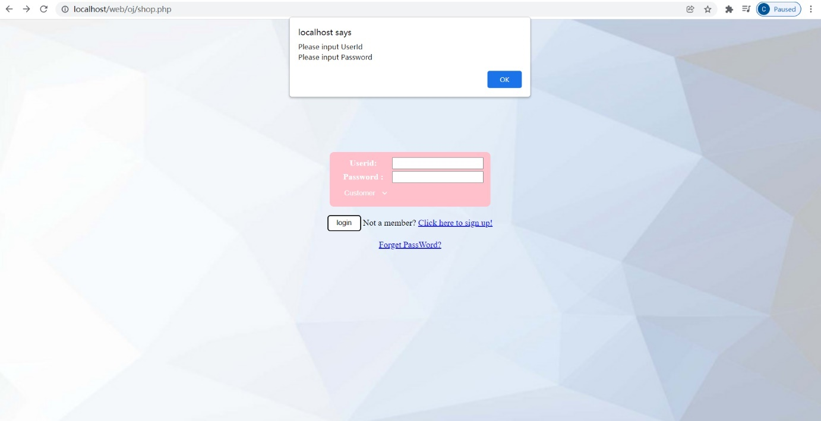

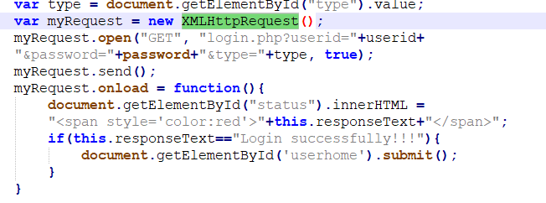

And in the php file, the userid and password will be matched in database to check whether the Id and password are correct. Meanwhile, a admin ID can not login as customer because it will also check the account type.

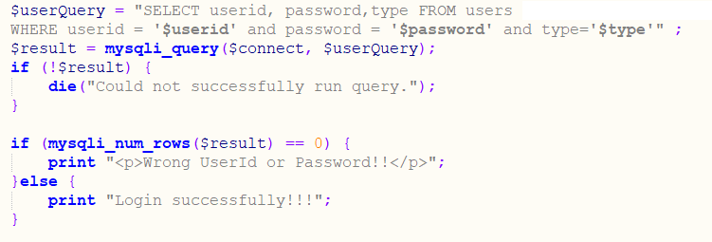

Both admin type and customer type account will head to *userhome page*, which will lead the admin to another *admin page*. In the *usehome* the login cookies will be updated and a userid session will also be created for future use.

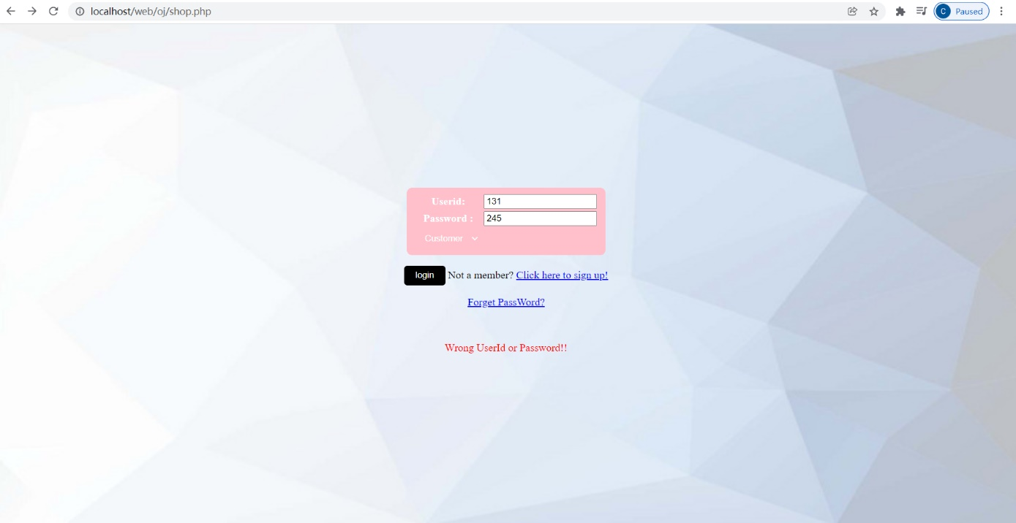

## Sign up and Forget password

In the login system, there are two links separately lead to *sign-up* page and *reset* page. In this part, I will show the structure of *sign-up* page and *reset password* page.

In the *sign-up* page:

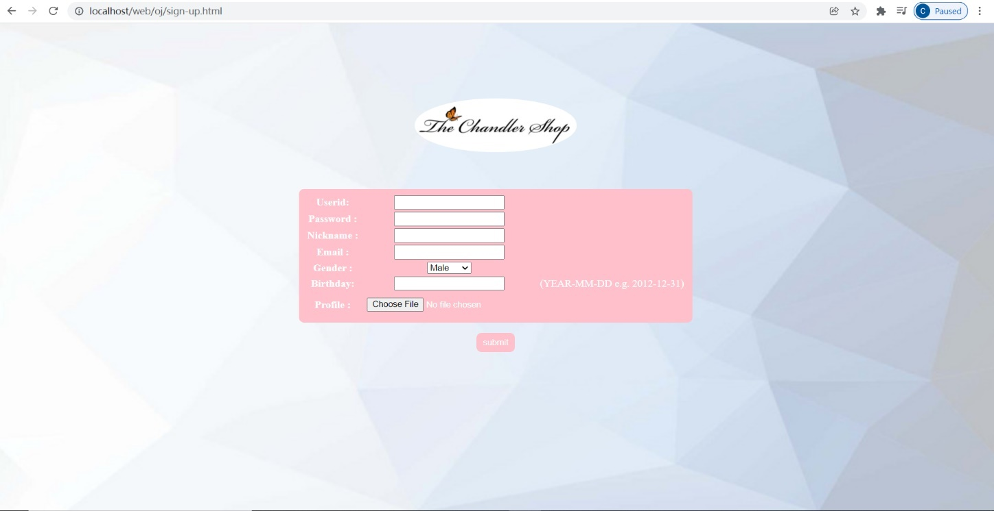

This page contains a table for users to input basic information and a file input to upload profile. When user click submit button, it will call a verify function in *sign-up.js* to check if there are valid inputs of userid and password. Then the JavaScript file will pass data to *sign-up.php* using JSON to check whether the userid is already registered. If not, the form in *sign-up.html* will be sent to *registered.php* to insert into database. After that, it will head to *userhome page* again.

The code will be shown below:

*.html file*

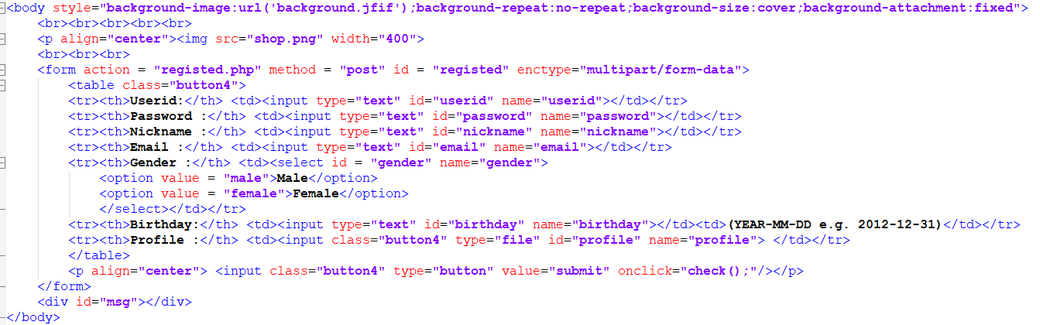

*.js file*

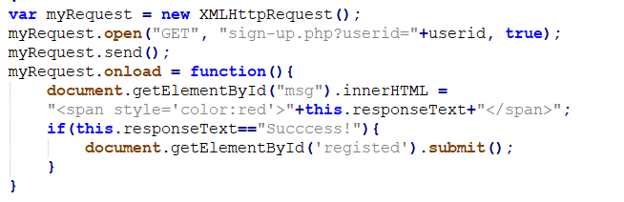

*Invalid ID*

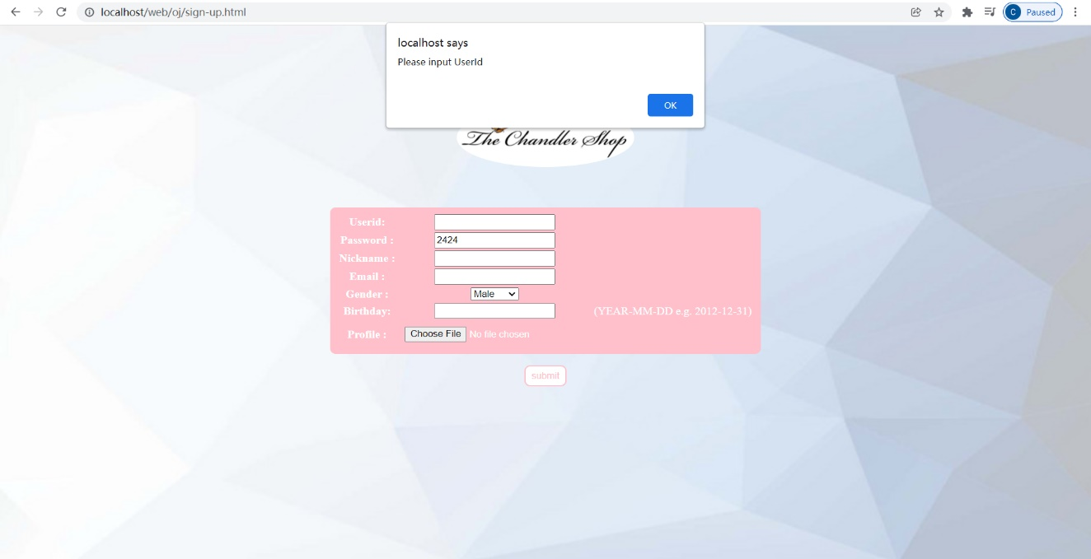

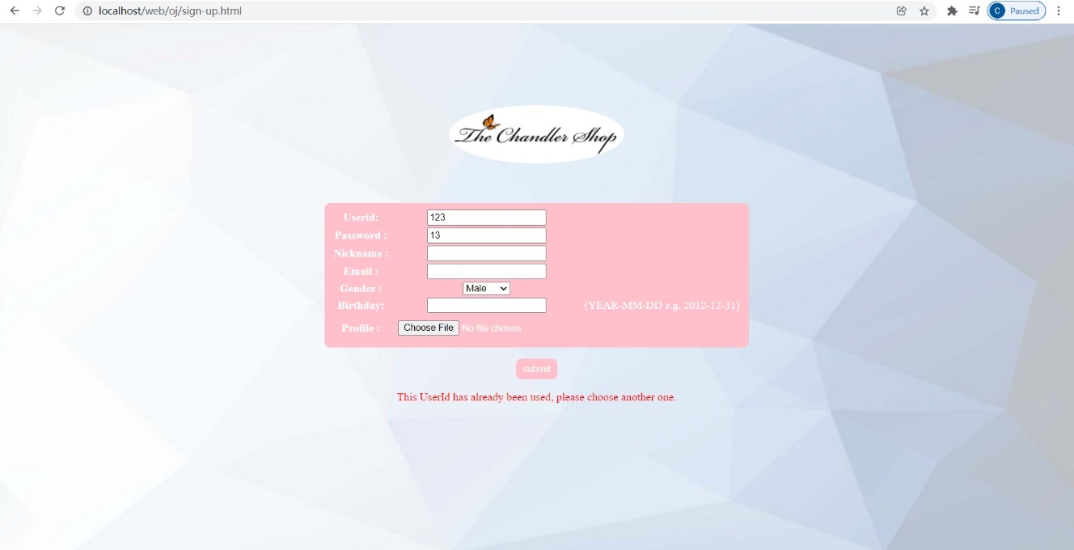

*.php file*

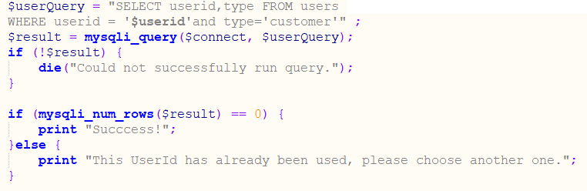

*registered.php*

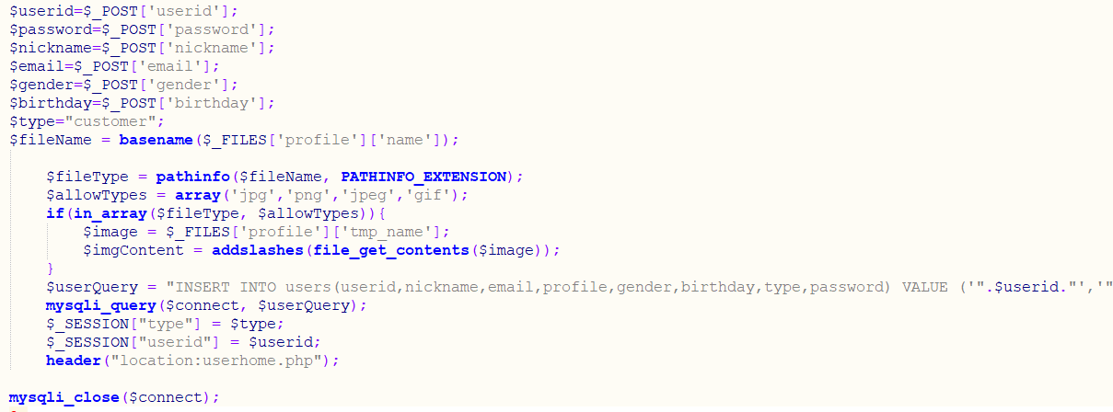

For the reset password page, there are only two inputs (ID, new password). It has the same working flow as sign-up system.

*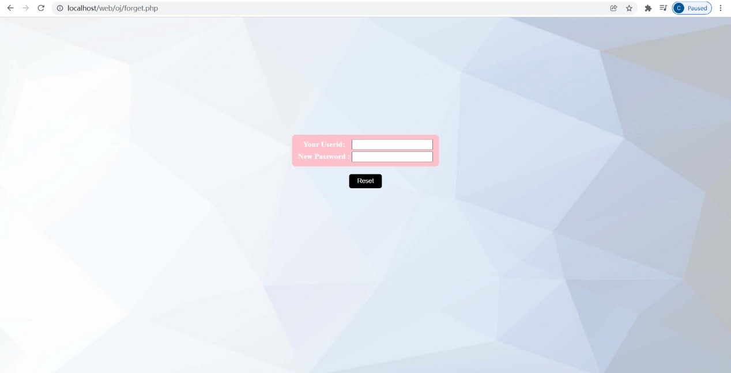reset*

*.php file*

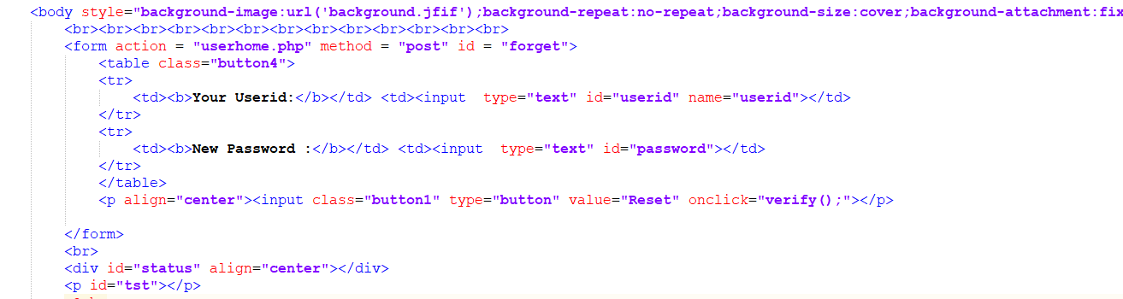

It will call a JavaScript function to verify the input and pass data to a PHP file using JSON just like *sign-up* system. If the userid matches a record in database, the password of the ID will be update with the new password, and the cookies will be reset.

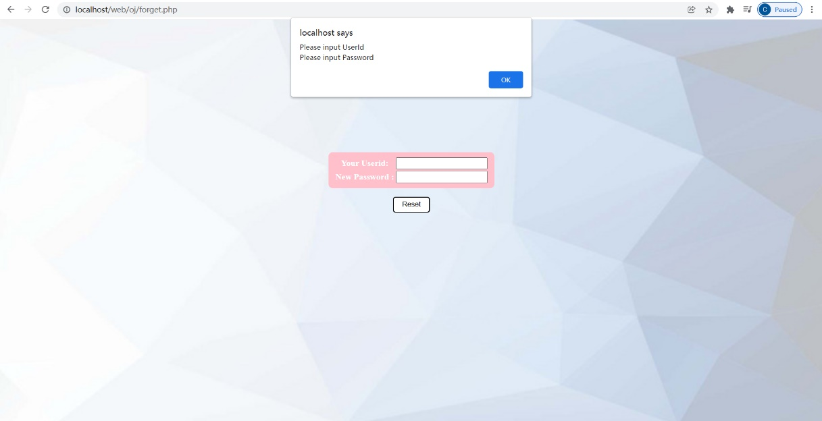

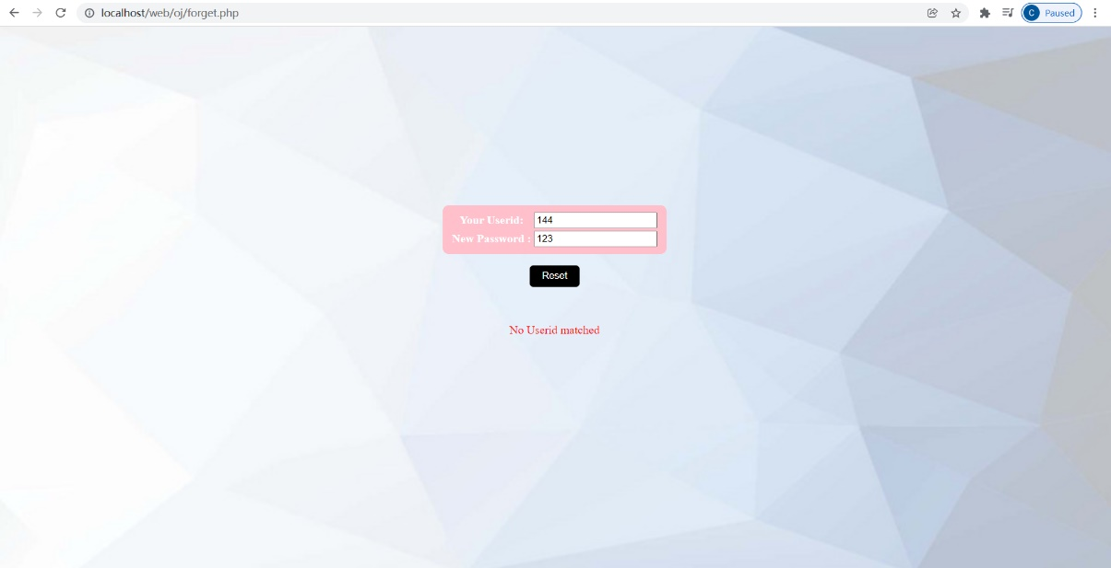*Wrong userid*

*Reset.php*

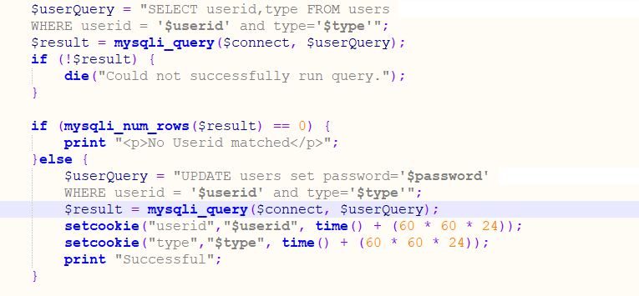

## Userhome (customer purchasing)

After user sign-up and login, it will come to this home page.

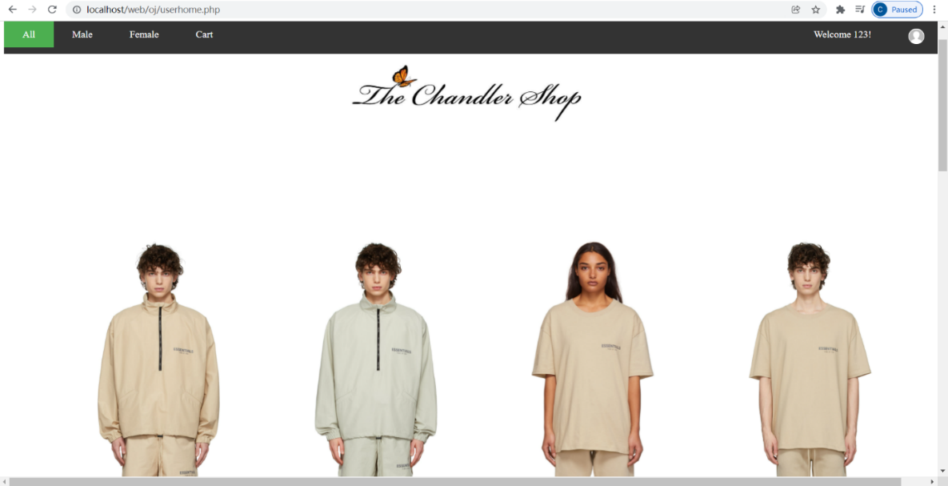

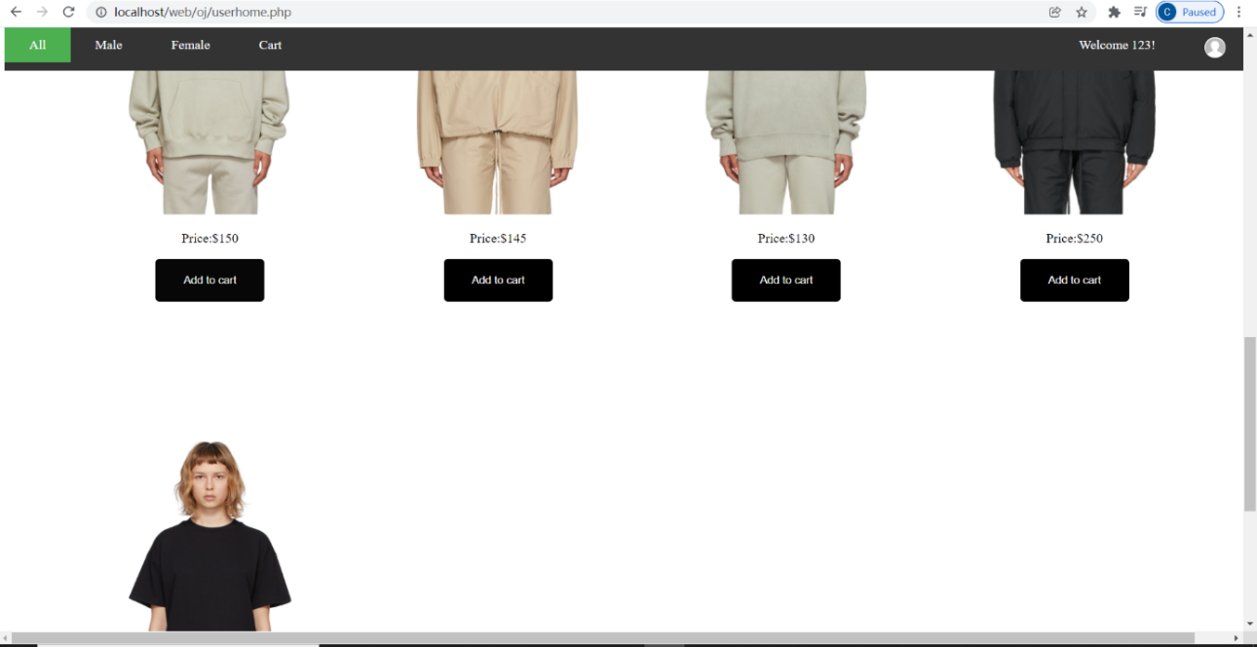

A bar is fixed on the top of the website, which shows the shopping category and current location. On the right side of the bar, a welcome message including the nickname of the user is displayed and the profile is also shown. A logo is shown below the bar and then follows the clothes.

This user doesn’t have a profile, so the system will display the default profile. The default profile is stored in the database as in user table. And the website will use it when it cannot find a profile file.

When user clicking the categories, the website will change its content by heading to different *.php* pages.

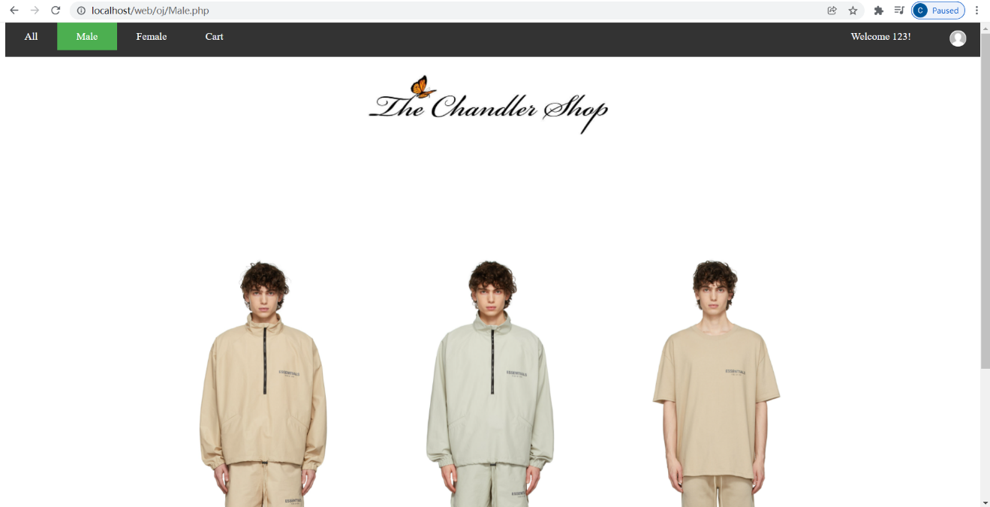

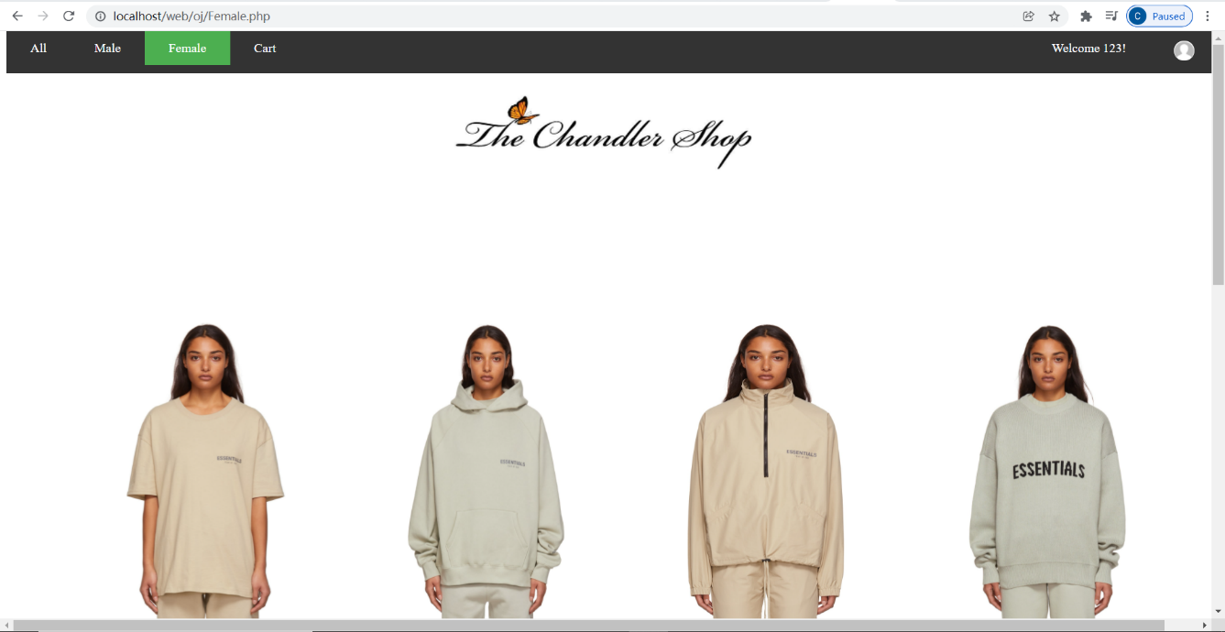

The bar is realized by using a list <ul>. And I add some modification in the CSS code so that it is very nice-looking and useful. First, I change the locations and color of the list. And I add a class called “active” to show the green color when it is chosen. Then I add a hover modifier to make it change color when my cursor is hover on it. For each list, I add a hyperlink to it, so it can head to other pages when I click it. And the category shows different picture in different pages by adding condition type=’male’ or ‘female’ in query. Also, need to use 64byte decode to get the picture of item from the database. The code will be shown below:

*.php file*

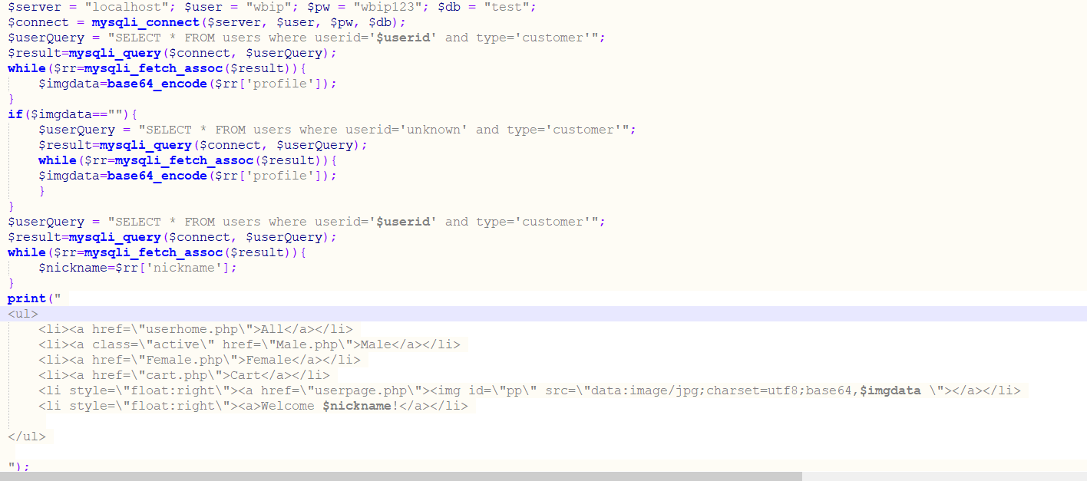

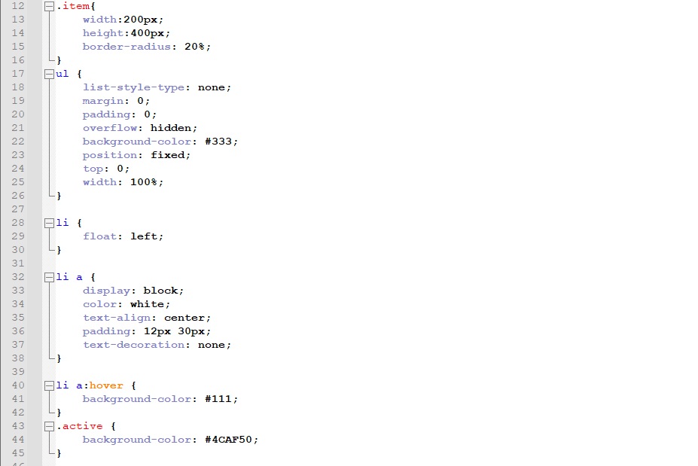*.css file*

Moreover, when I show the pictures of each item, I want to make sure they are aligned. So I use a no border table to put them in. Meanwhile, I want to show 4 items in one row. Because the <table> setting cannot make it change row automatically, I add a counting variable to count the number of items in one row, if it counts to 4, it will print</tr><tr> to start a new row.

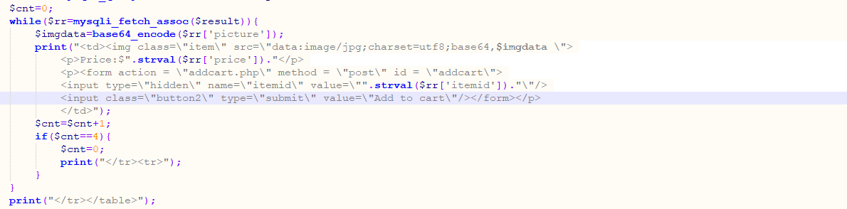

## Shopping Cart (optional function) and buying

Users can choose item and add them into shopping cart before buying them. In the shopping cart, users can modify the quantity of the items in the cart and press buy all button to buy all the staff in the cart. However, if the quantity of item in the cart is larger than item stock, the system will give an alert that the stock not enough and the purchase will fail.

If the customer wants to delete items from cart, he or she just needs to modify the quantity to zero.

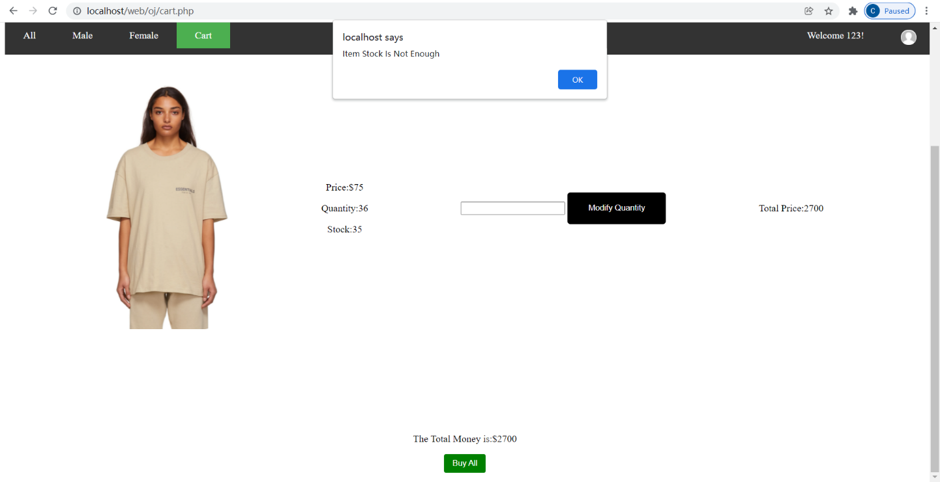

This function is based on the database table cart. *Cart* table has the record of *userid* and *itemid* that currently in the cart. It also records the item price and quantity. So when the user press *buy all* button, the web will call verify function from *cart.js* to verify if there is enough stock. If the result is successful, the page will be sent to *buy.php* to execute the buying operation.

In the buying process, the quantity of items in *item* table will be subtracted by the quantity in *cart* table if the *itemid* in the cart *table* is equal to *itemid* in the item *table.*

After finishing buying process, the cart table will delete all the records which has the same *userid* with current *userid* (stored in session).

The code of buying item in cart will be shown below:

*.php*

**

*.js file*

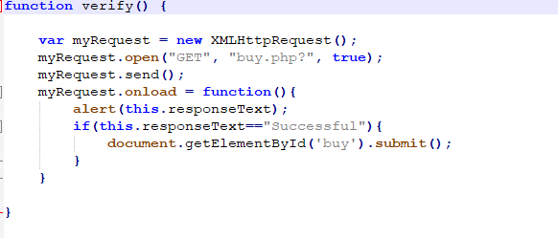

*Buy.php*

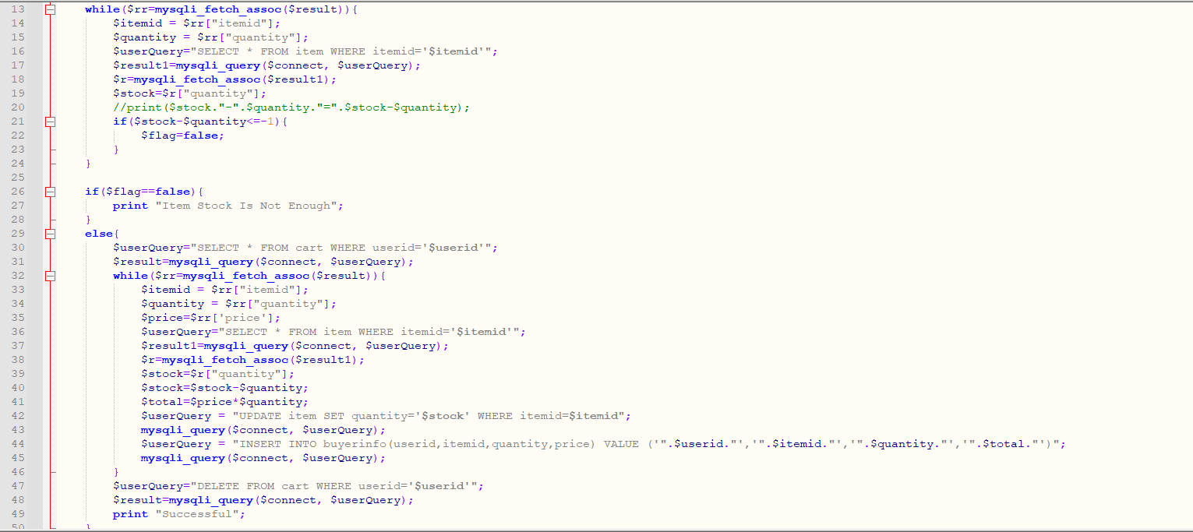

## Userpage (extra function for modify user info and see purchase history)

If users click the small profile on the top left of the web page, the web will enter *userpage*, in which users can see their profile picture and a function list.

The function list includes quick access to *userhome* (shop page), cart and it can display the purchase history or modify the basic information of the user. Meanwhile, user can also log out by clicking log out button.

*userpage*

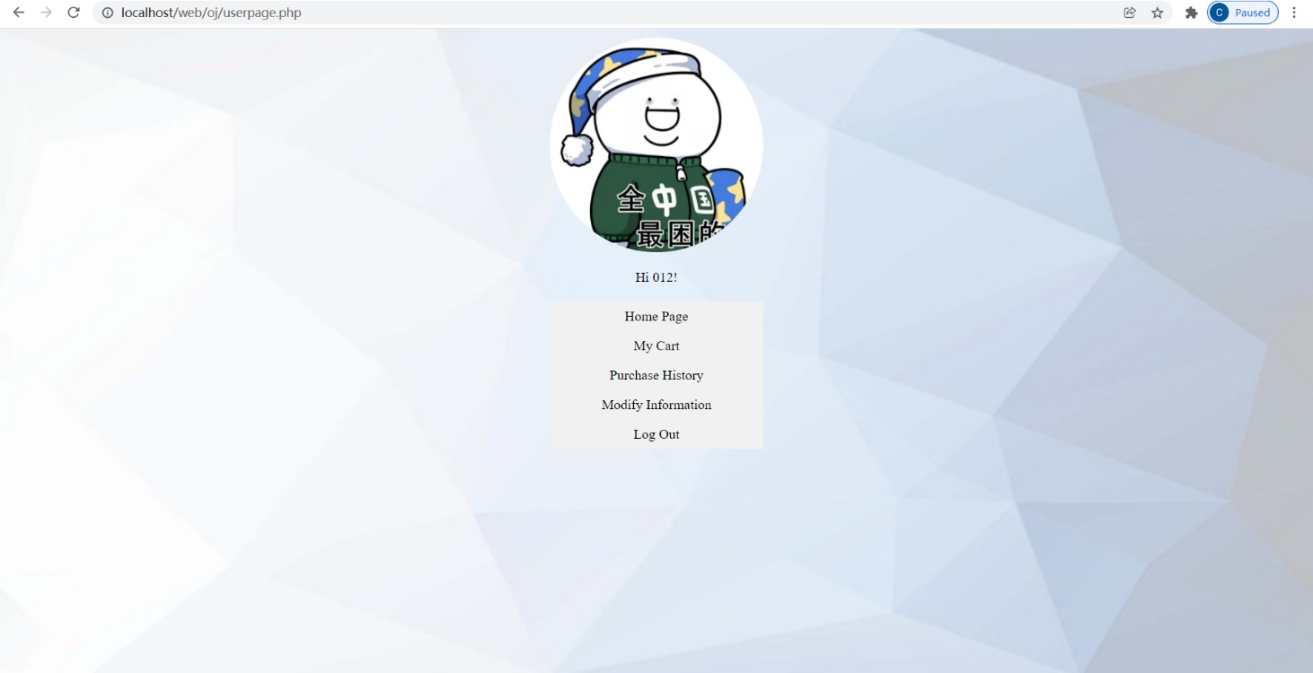

When user click purchase history, the web will head to *history.php* in which all the item that the user bought will be display. This function is realized by query the *buyerinfo* table with current userid.

*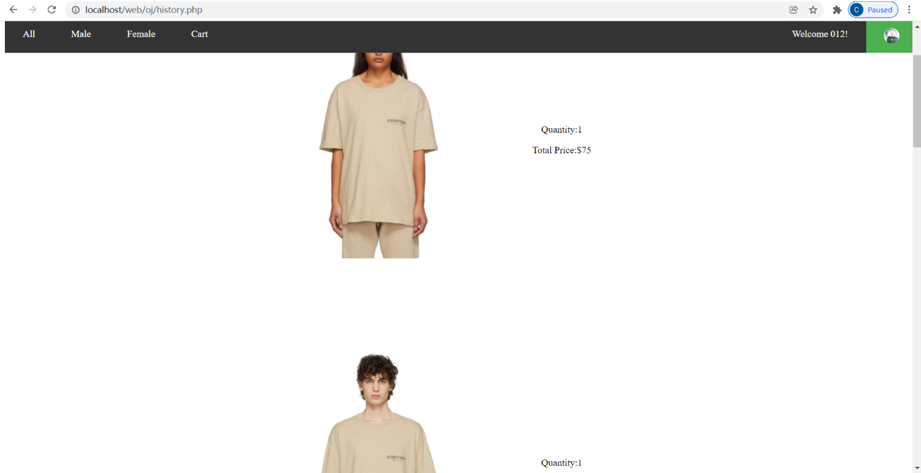History page*

*history .php*

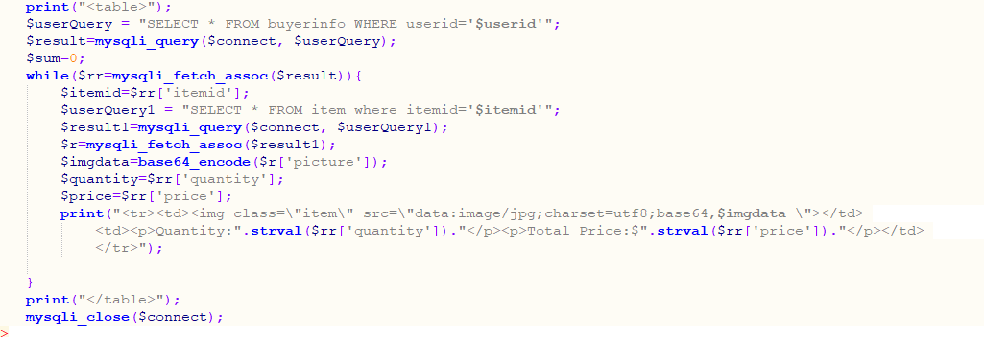

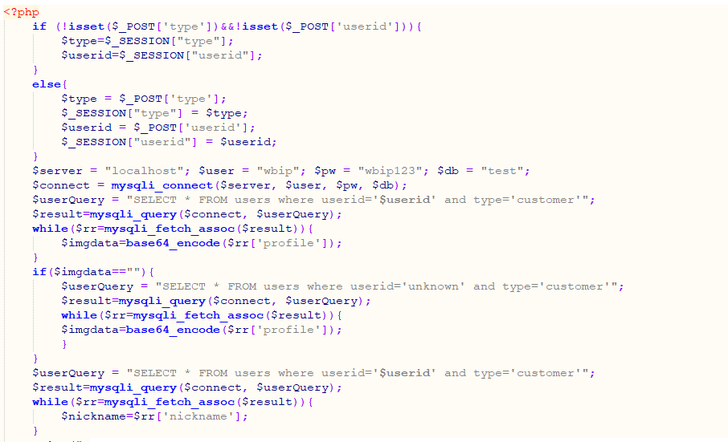

When the users click modify information. The web will head to *modify.html,* in which the users can modify the basic information including profile, nickname, gender, or even the password. However, userid is not allowed to modify.

*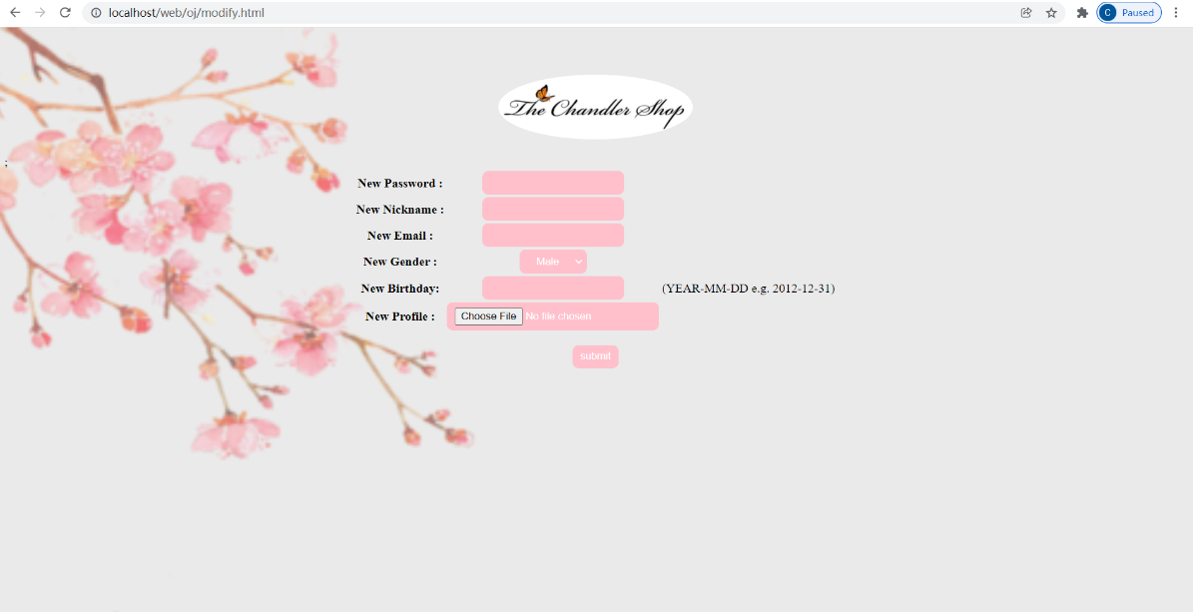modify page*

*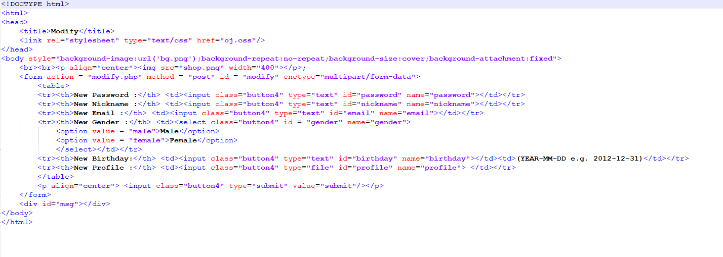modify.html*

## Admin Page (with optional function of showing the chart)

When I use a shop keeper account to login the system, I will not head to shop page(*userhome*), instead I will be headed to *adminpage*.

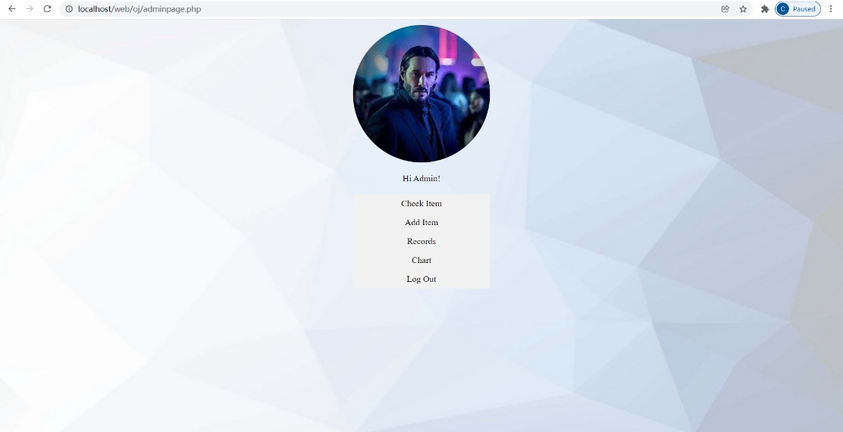

Admin page is similar to *user page* with a profile and a function list. However, *admin page* has different functions from user page.

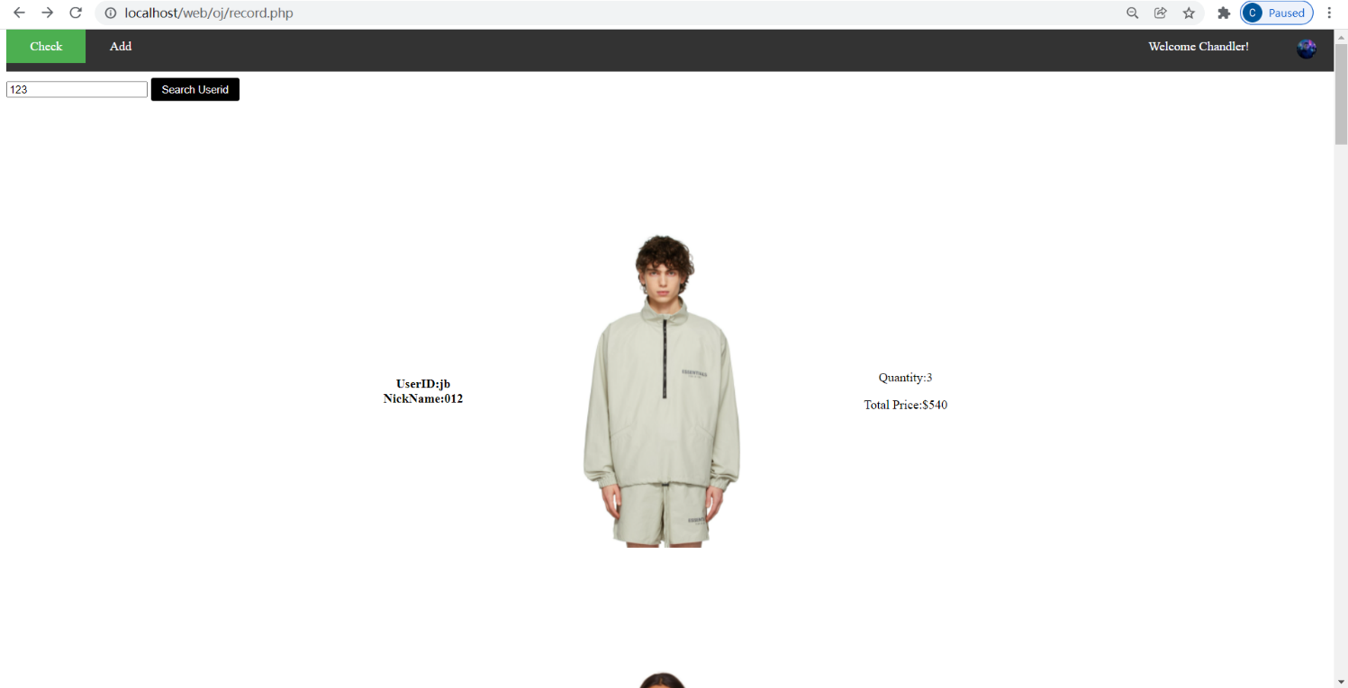Firstly, it has show-records function which can display all the customer purchase records and list them in ascending order of users’ nickname. Moreover, there is a searching bar in this page, shop keeper can search user id to gain the record of certain customer.

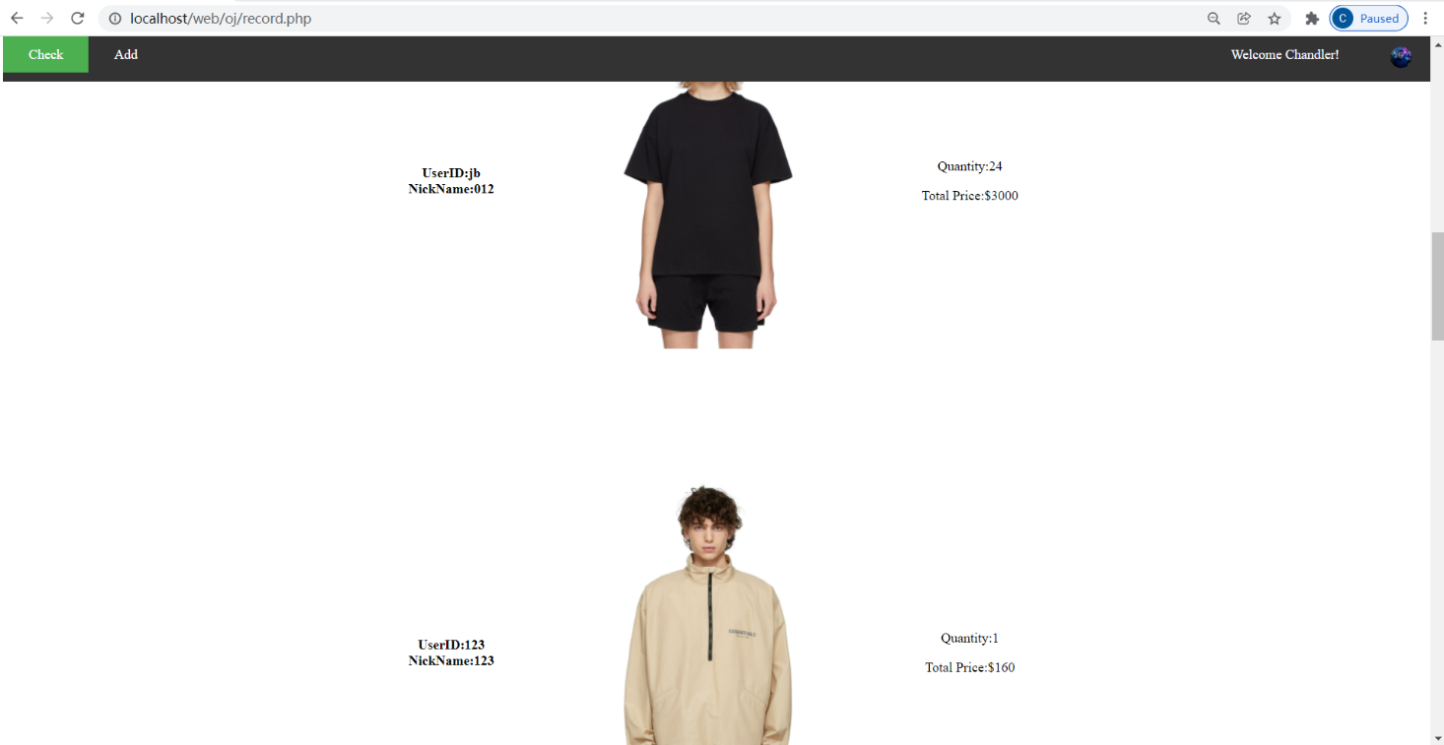

To realize this function, I use a join sql query and order the result by nickname.

*Record.php*

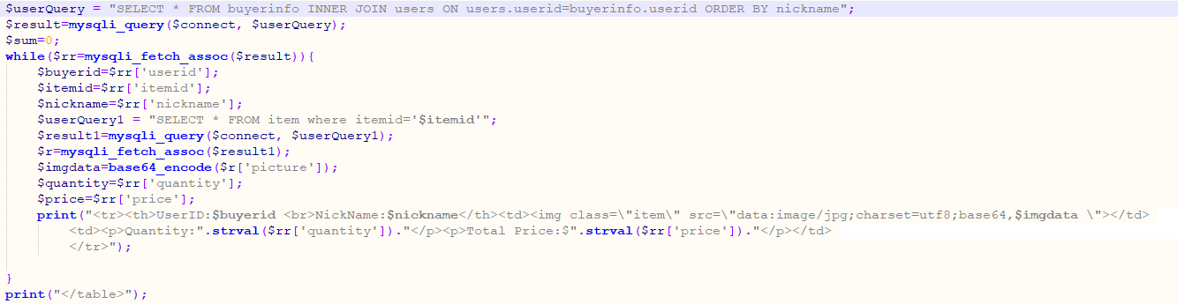

And for searching function, I use another page called *personalrecord* to display the searched results.

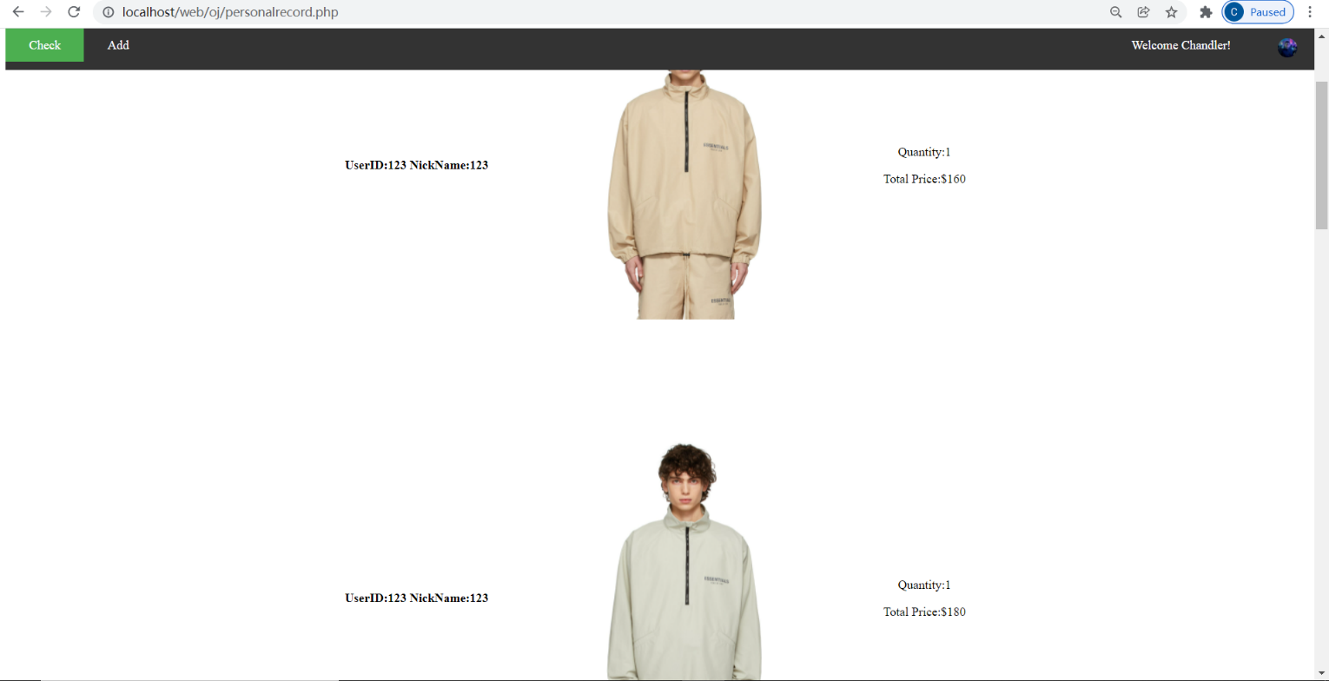

In this file, I modify the sql query to select from given user id.

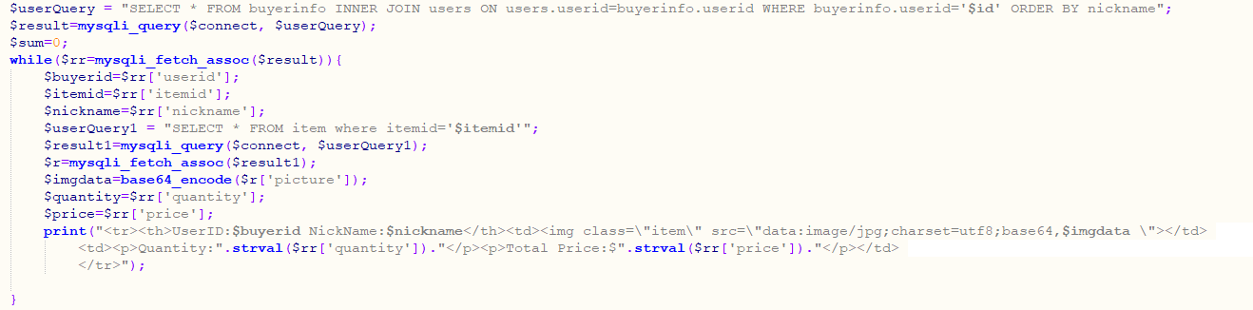

Secondly, the admin page has a show chart function, which can show all the items’ buying number in charts. The bar chart will be sorted in descending order and the top 3 best-selling item will also be display in a pie chart.

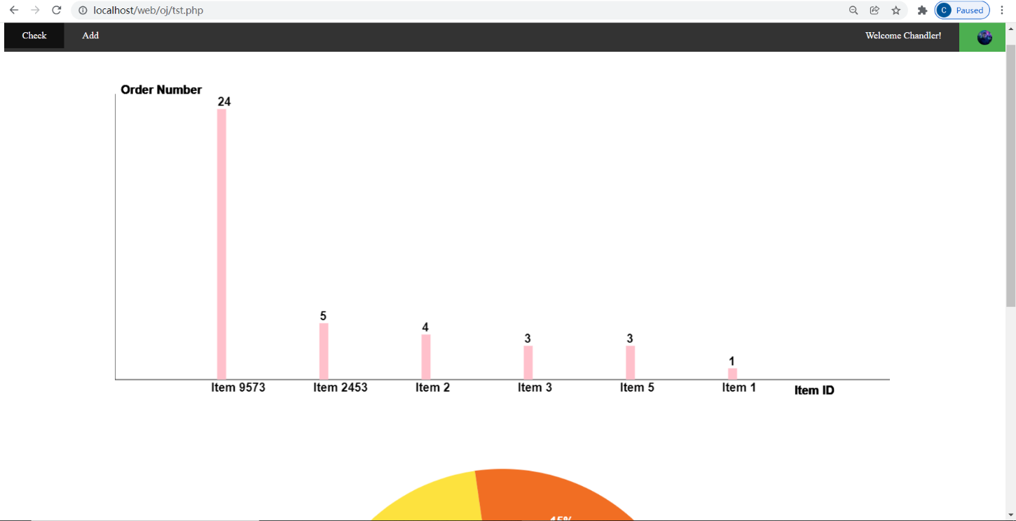

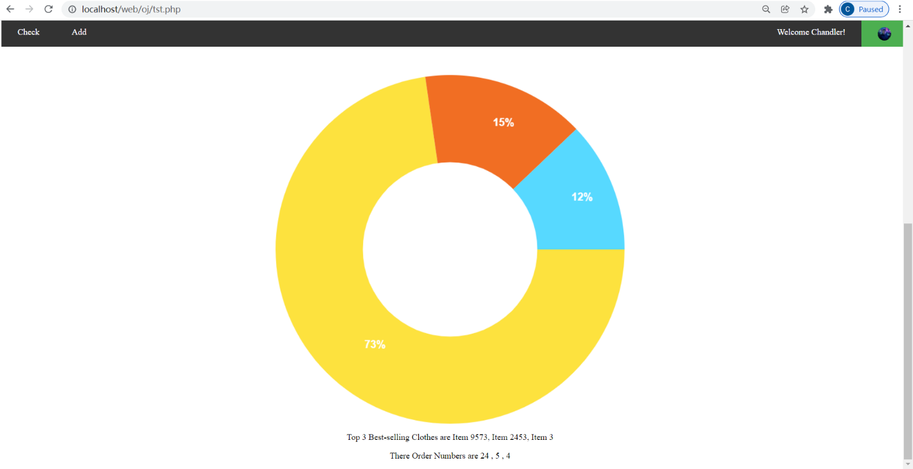

The bar chart shows the total buying number of each items in descending order. And the height of the chart will automatically suit the data so that all the data can be displayed completely.

The pie chart chows the percentage relationship of top 3 best-selling items. For example, the total number of top 3 best-selling item is 24+5+4=33.

For item 9573 it has 24/33*100=73 percent. And for item 2453, the percentage is 5/33=15%.

To draw these charts, I use JavaScript and Canvas as my tool. First, I get all the data (including sum) of buyerinfo and make them in descending order using SQL query.



Then I put these data into two arrays (one is to store item id and the other stores cnt(sum)).

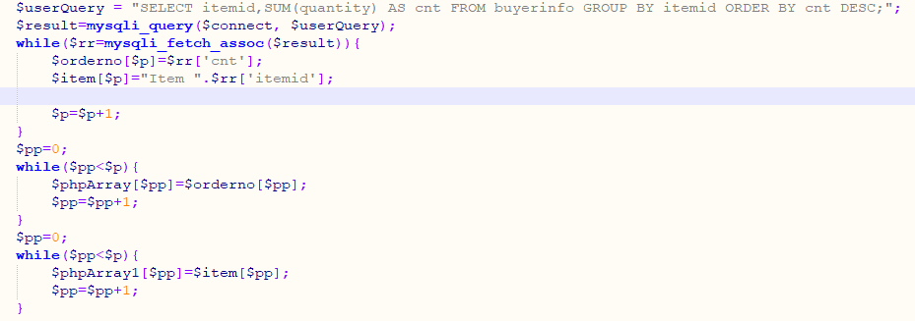

*Orderno[]* stores item number, and *item[]* stores item id. And I pass these two arrays to JS using JSON format.

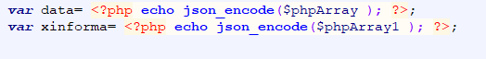

Meanwhile, I add a *windows.eventListener* to run the function of drawing chart. In the JavaScript part, I get the defined canvas by id, and set its weight and height. And the most important step is to get the *context(“2d”)* as *ctx*. After that I use *ctx* to realize all the drawing functions including drawLine() and drawPieslice. Then I combine these two methods to draw out my bar chart and pei chart based on JSON data.

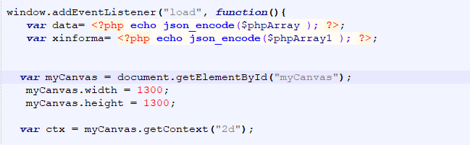

*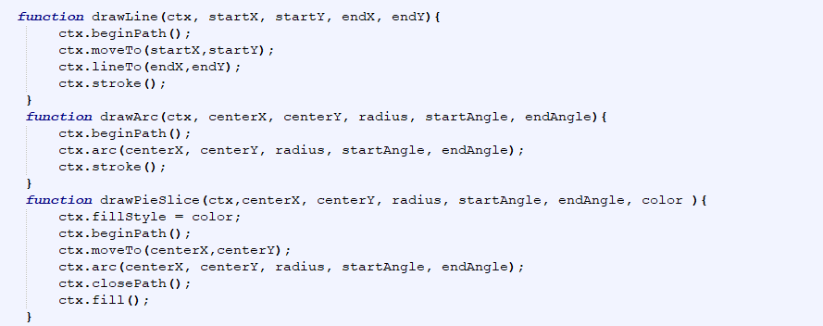Some methods*

In the bar chart method, I set a *maxv* variable to get max value of data and set its bar height equals to max height. Then the others are proportional to its height. After that, I just need to use a for loop to draw all the bars.

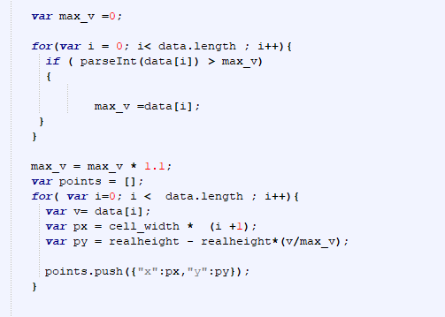

In the pie chart method, I mainly use drawPieSlice function after calculating the rate of each part. After that, I draw a white circle in the middle of the pie chart to make it a ring shape which is more beautiful and straightforward. Then I use fillText method from context to write down each part’s percentage.

*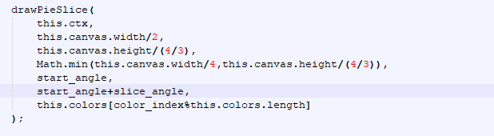using drawPieSlice*

*using fillText*

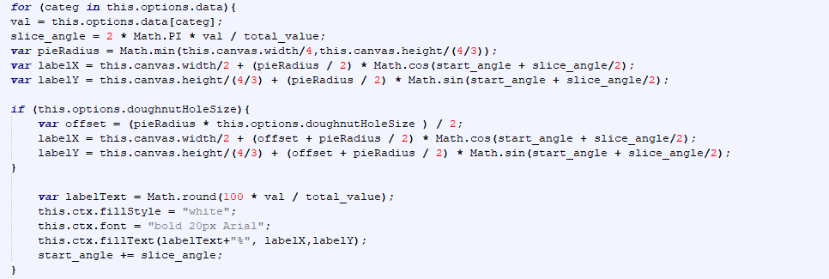

At the same time, admin can adjust the item or add new item by clicking *check item* or *add item.*

*Check*

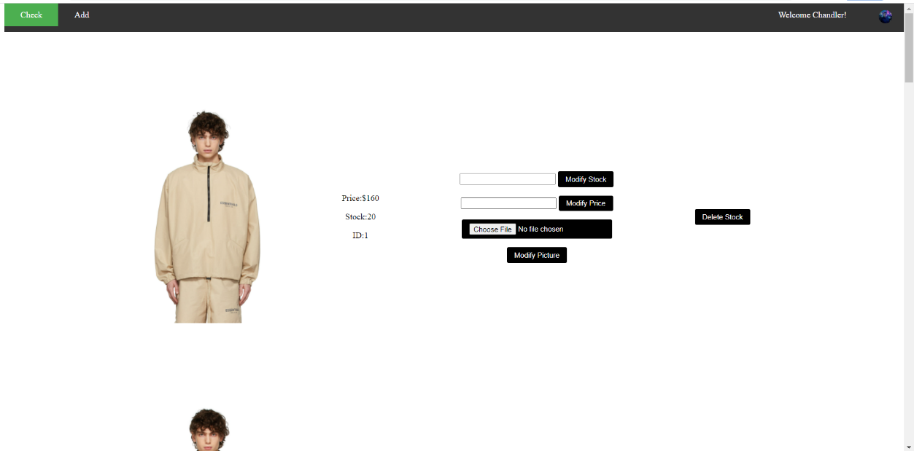

In the check page, shop keeper can modify the price, stock and even picture of the item. And the delete button will delete the item from *item* table.

*Check.php creating table*

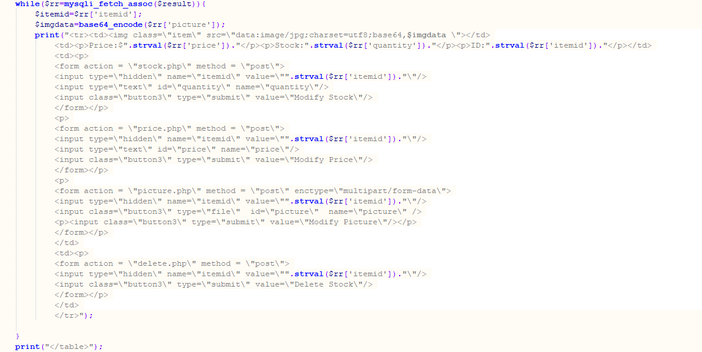

Each button in the table will lead to another php file which will do the operation like modifying price or change picture.

*Modify stock*



*Modify price*



*Modify price*

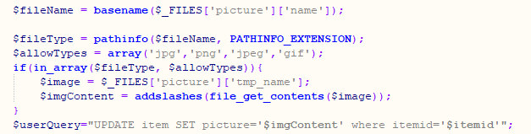

*Delete item*



## Logout

Logout system is a very simple php file. To log out a user, the system just needs to clear all the cookies and sessions, then head to login page.

*Logout.php*

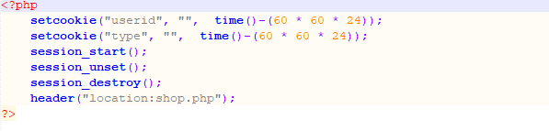

## CSS

Up to now, all the function has been finished, including extra feature and some advanced function. So I just need to add CSS file to my website.

There are two CSS file in total, the first one is *oj.css* and *shop.css*. The *shop.css* is applied to shop page (*userhome, male, female*). The *oj.css* is for all the other files.

In oj.css, there are table style setting, image style setting, list style setting and button style setting.

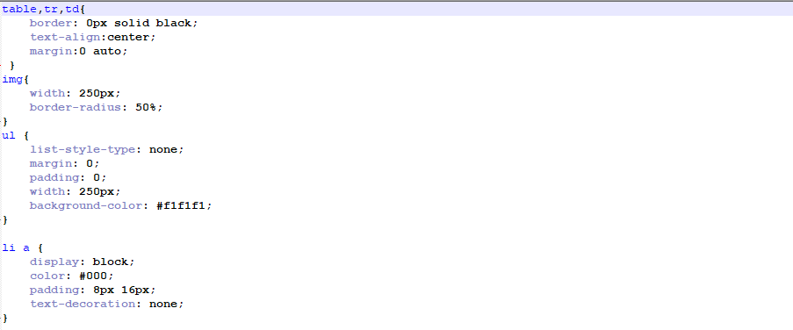

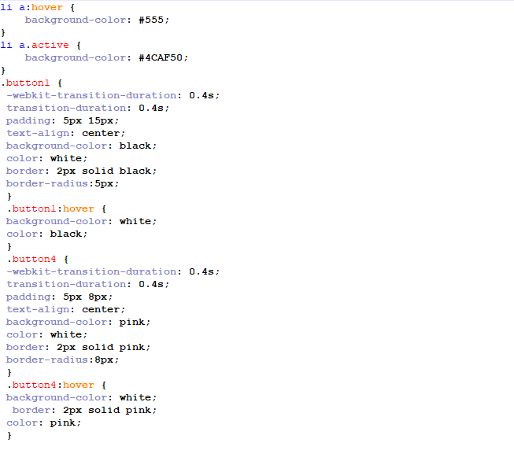

The table style makes sure there is no border in table and the table will be in the center place. The *ul* and *li a* setting help me to build the UI of *userpage*(also *adminpage*)

*List setting*

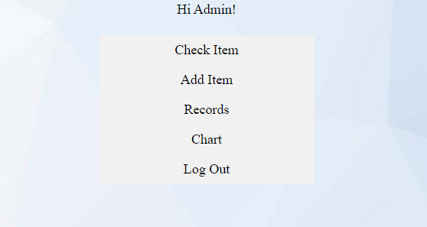

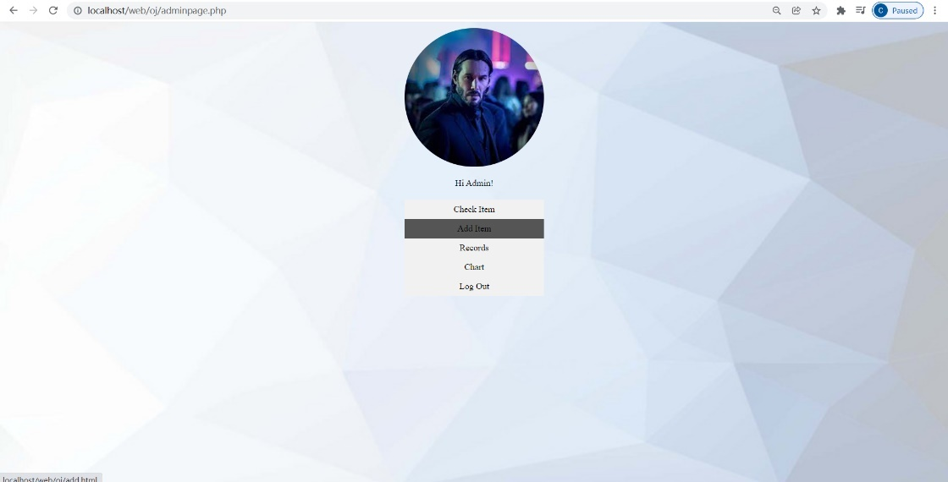The *li hover* make the list changes color when my cursor is hover on it.

And the *button* class modifier is used to modify all the input type.

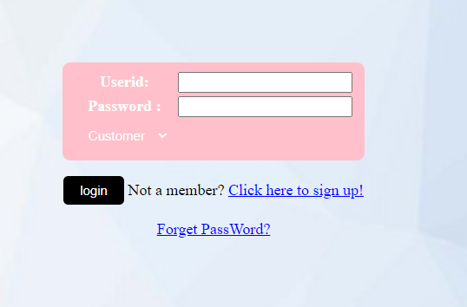In the login page, the table is applied with *button4* class, and the button is applied with *button 1* class.

*When I put mouse on the table*

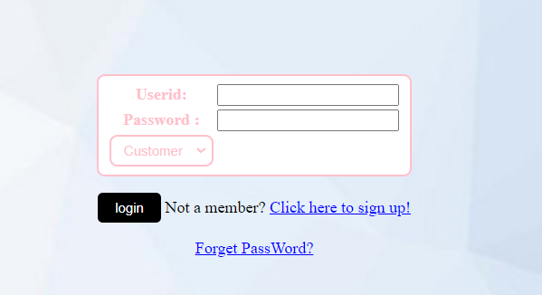

*When I put mouse on the button*

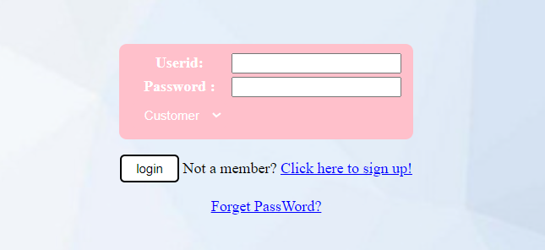

In *shop.css,* the main different is the li, ul part. And there are more image style for item and user profile.

*ul,li*

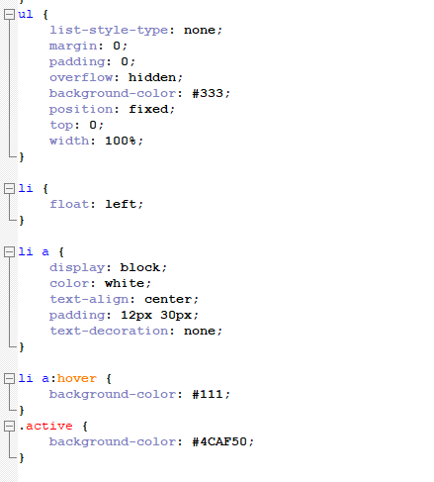

*For class =item and id =pp*

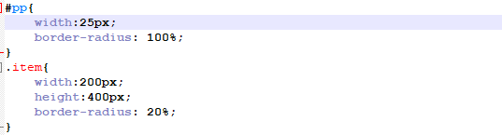

*Result of list modifier and id=pp (profile)*

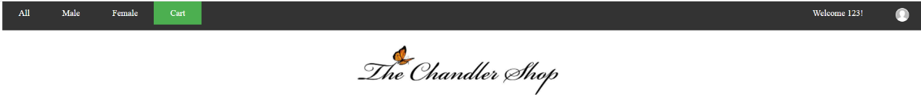

*New button modifier*

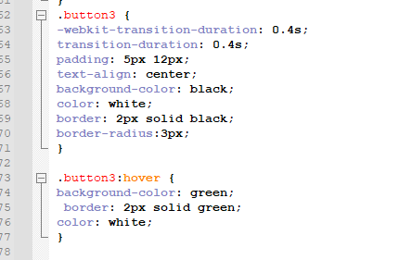

*The result of button*



*When I put mouse on button*



# Function List

## Customer Registration

Customer sign-up with basic information (id, password, nickname, email, gender, birthday, profile). They can update their information in their personal user page. And admin don’t need to sign up.

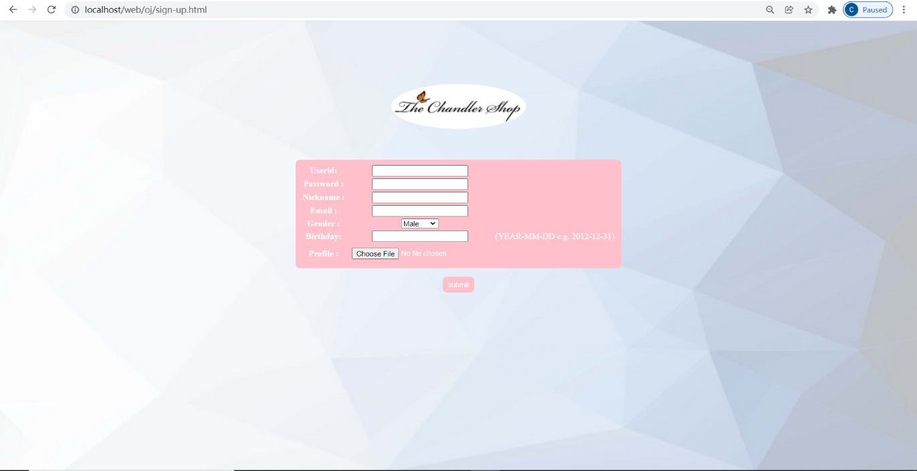

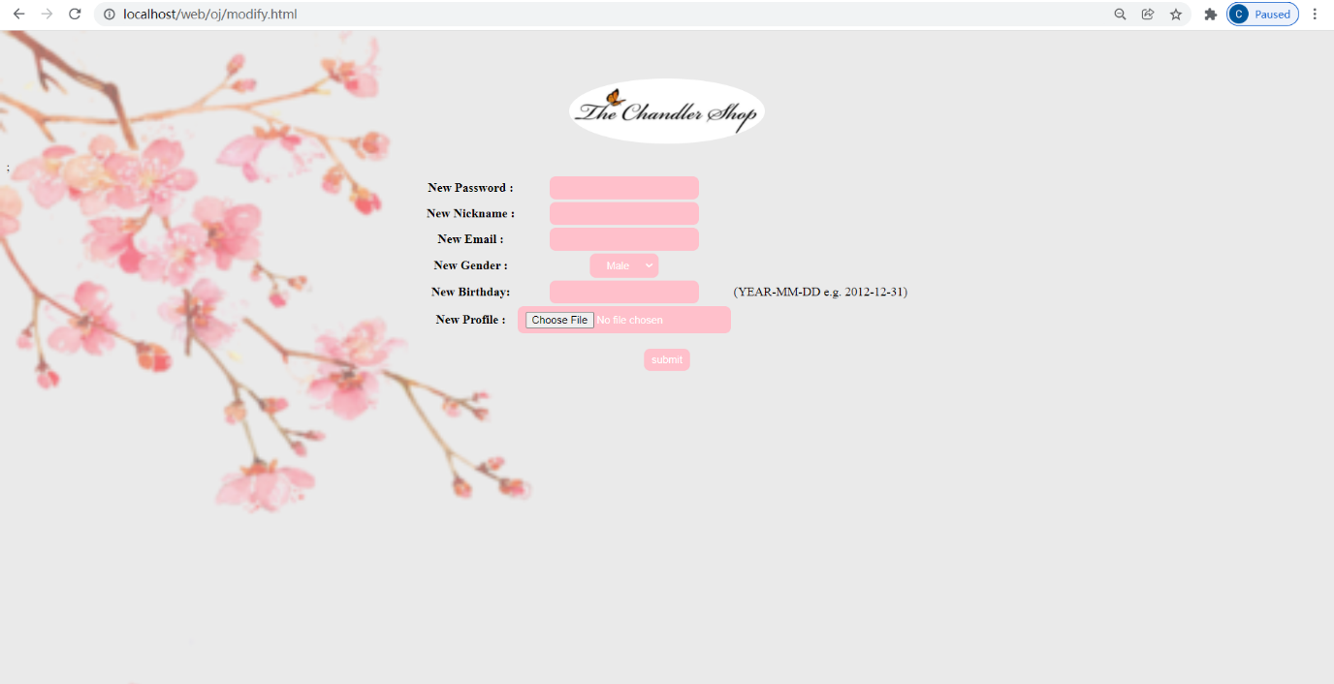

## User login (logout, with cookies and sessions, reset password )

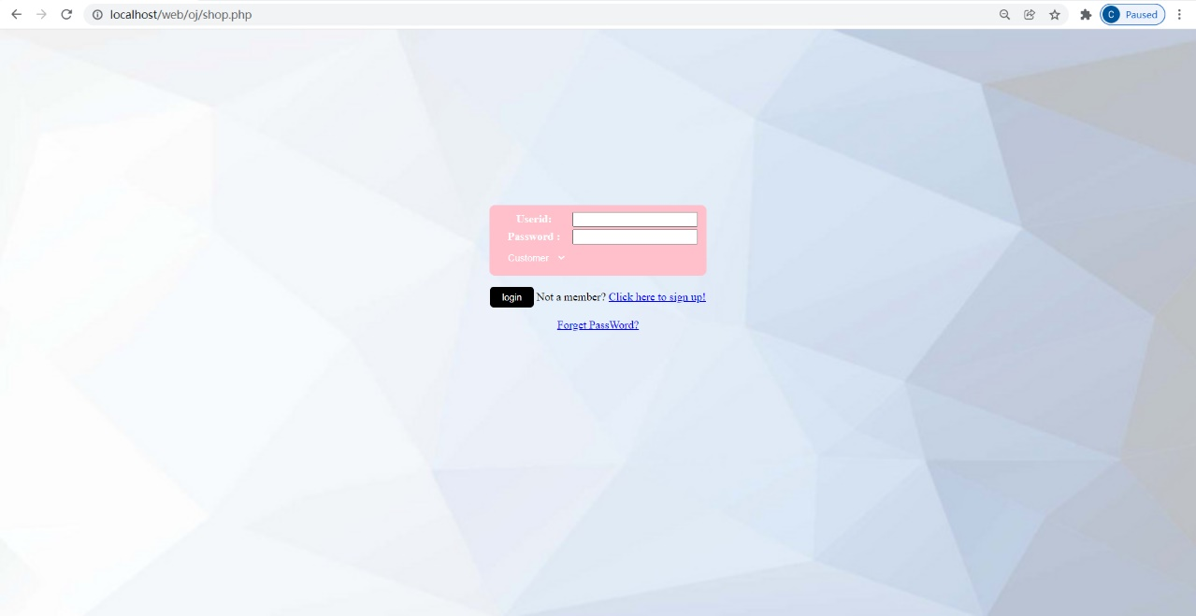

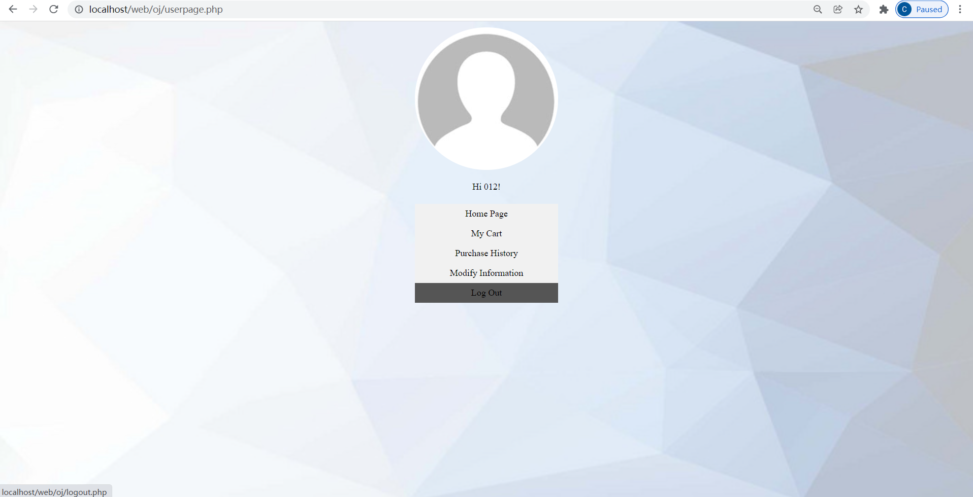

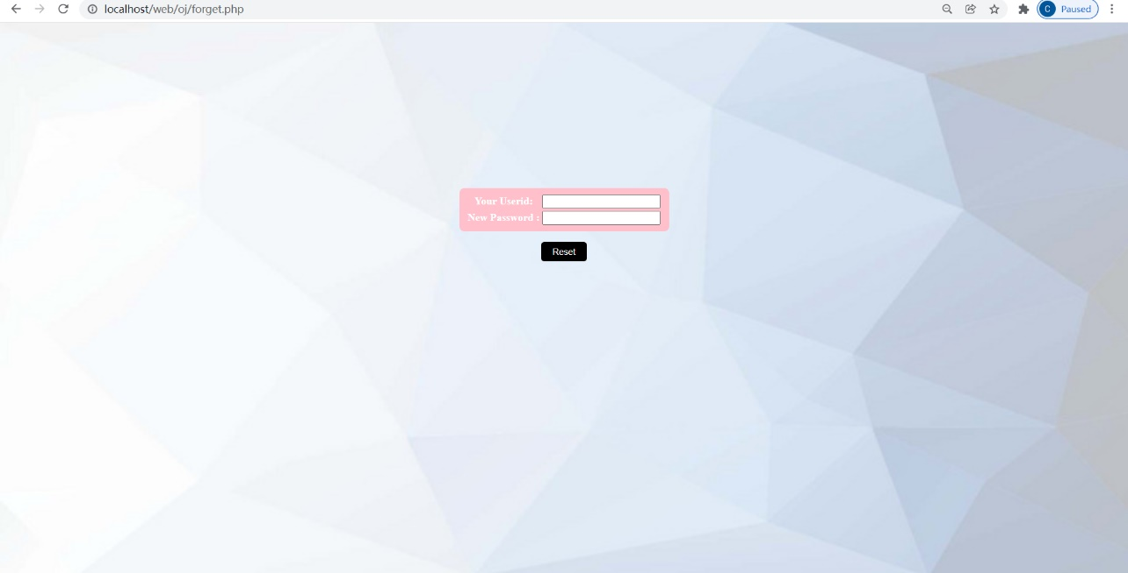

## Customer purchase clothed

### User Page

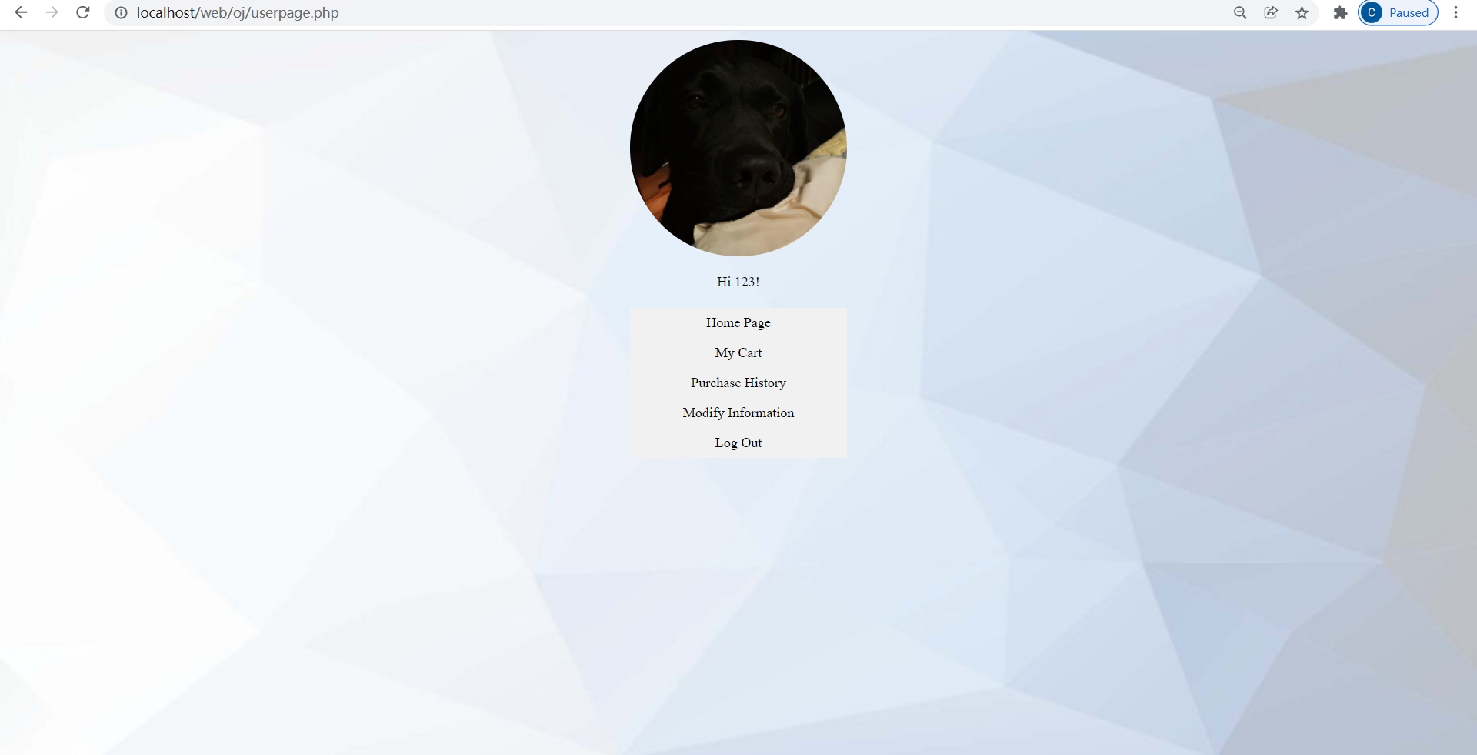

### Brows all kinds of clothes

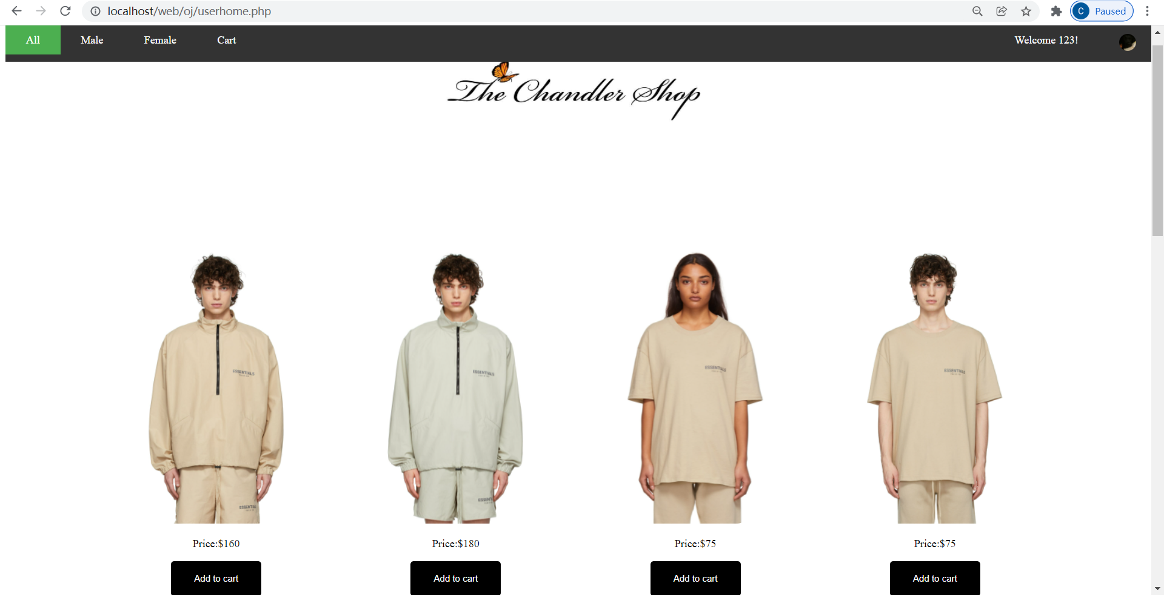

### Categories (Male, Female)

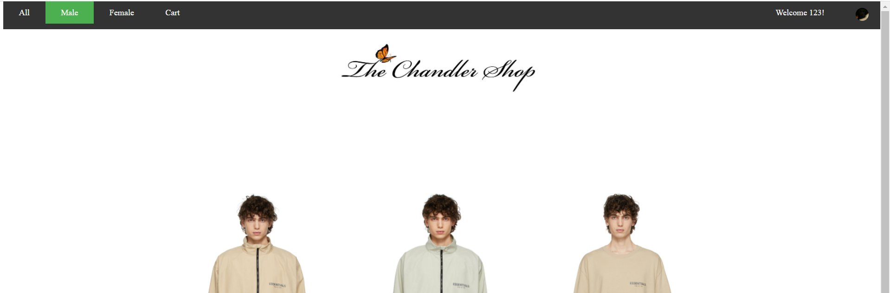

### Shopping cart with Buying check

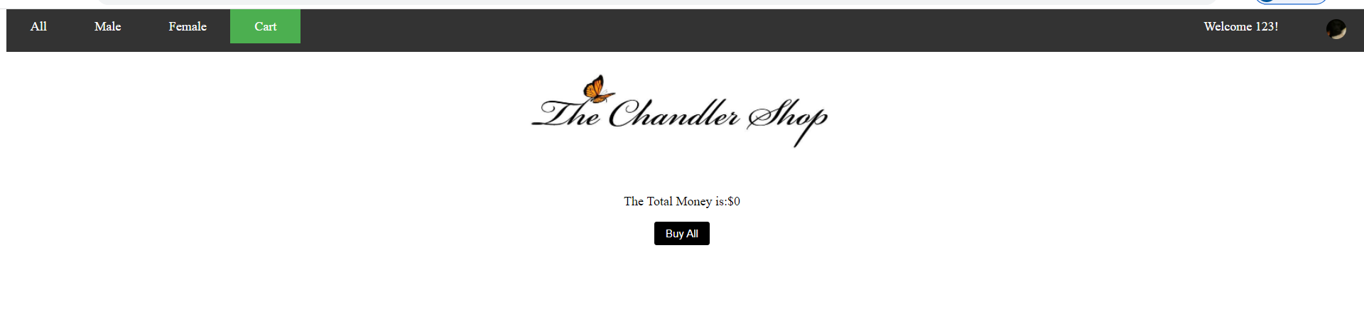

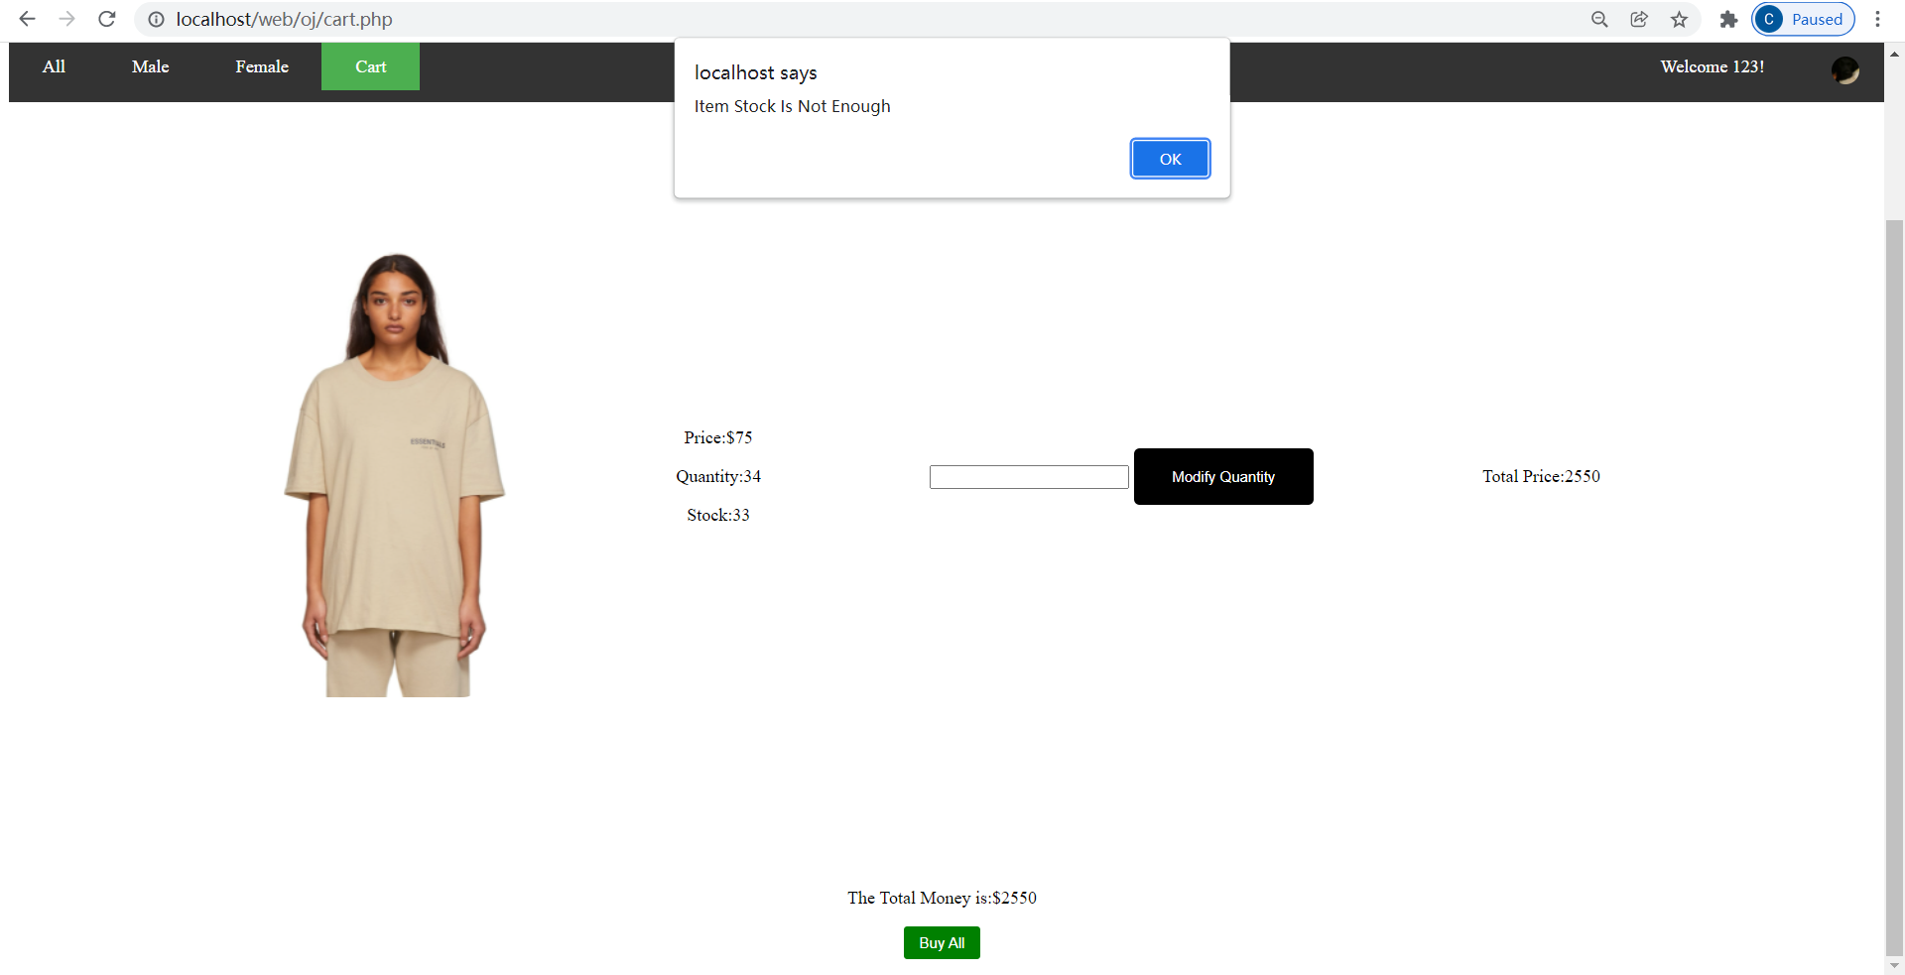

### Purchase History

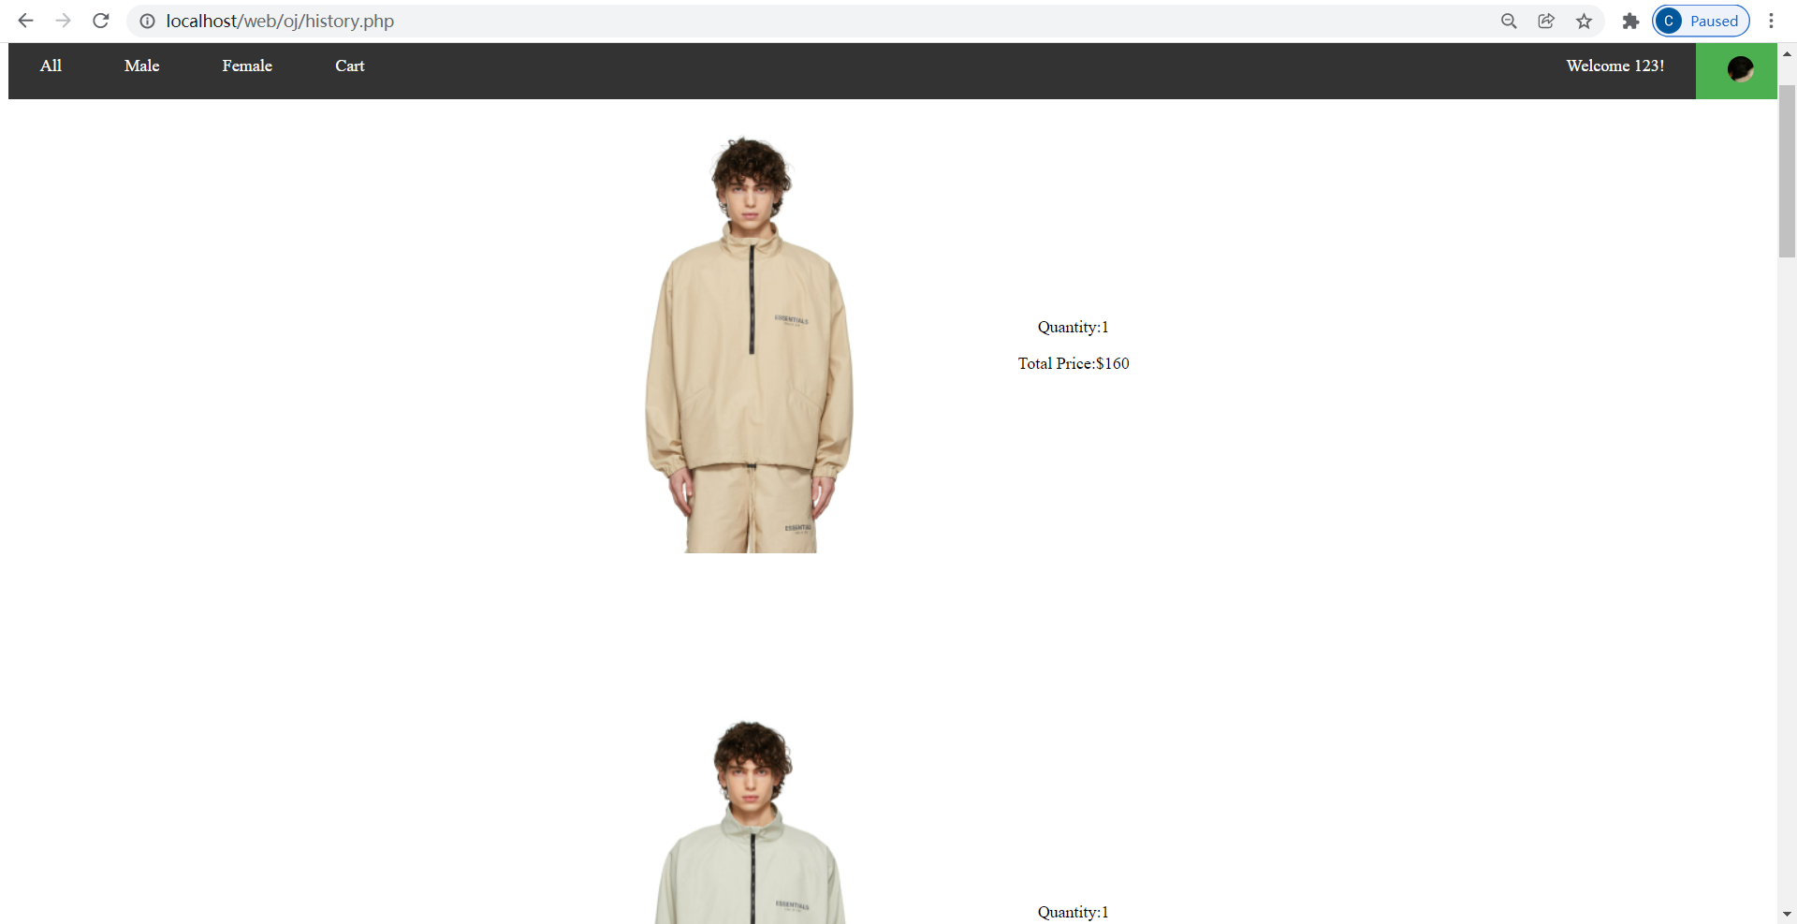

## Shop keeper page

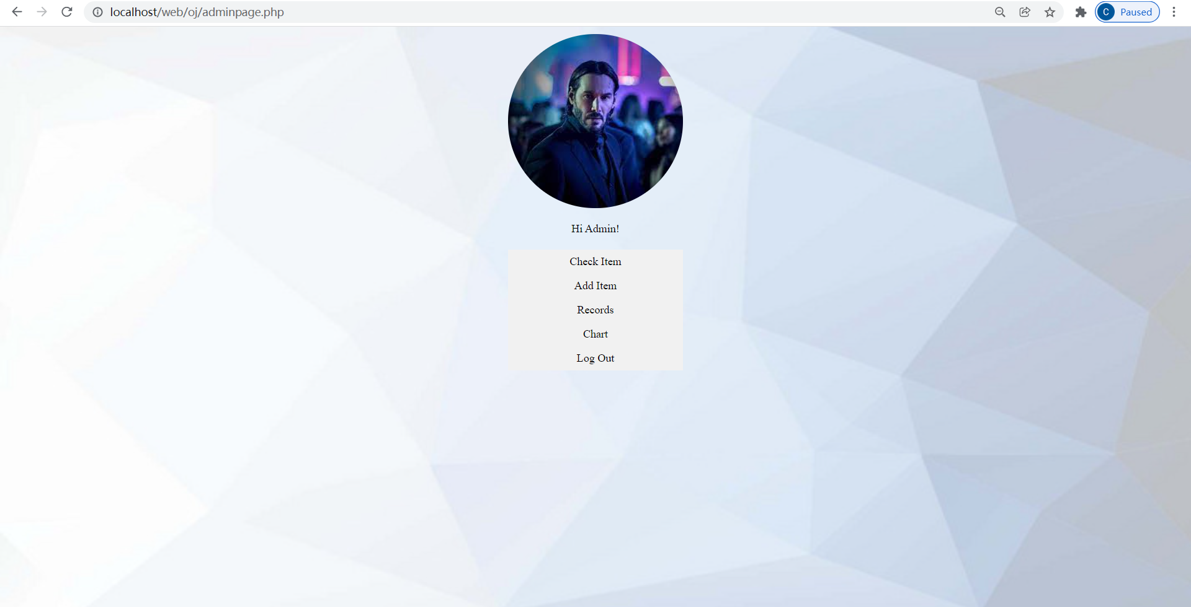

### Check item (Modify stock, price, picture. Delete item)

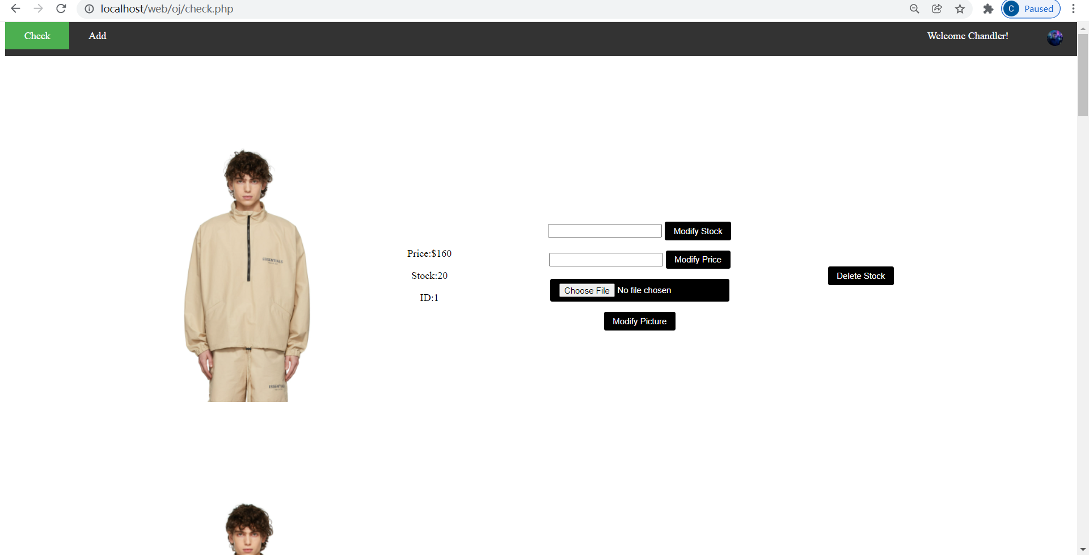

### Add new item

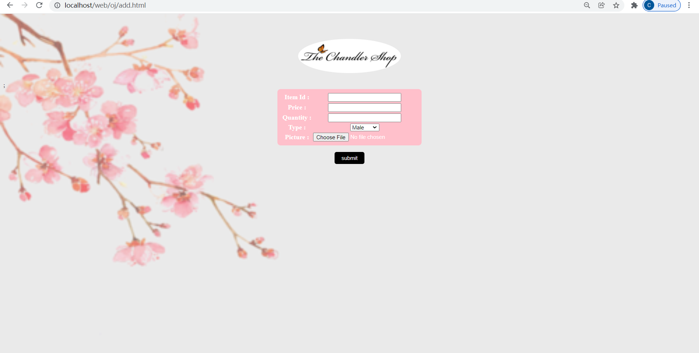

### View records (Order by nickname, search ID)

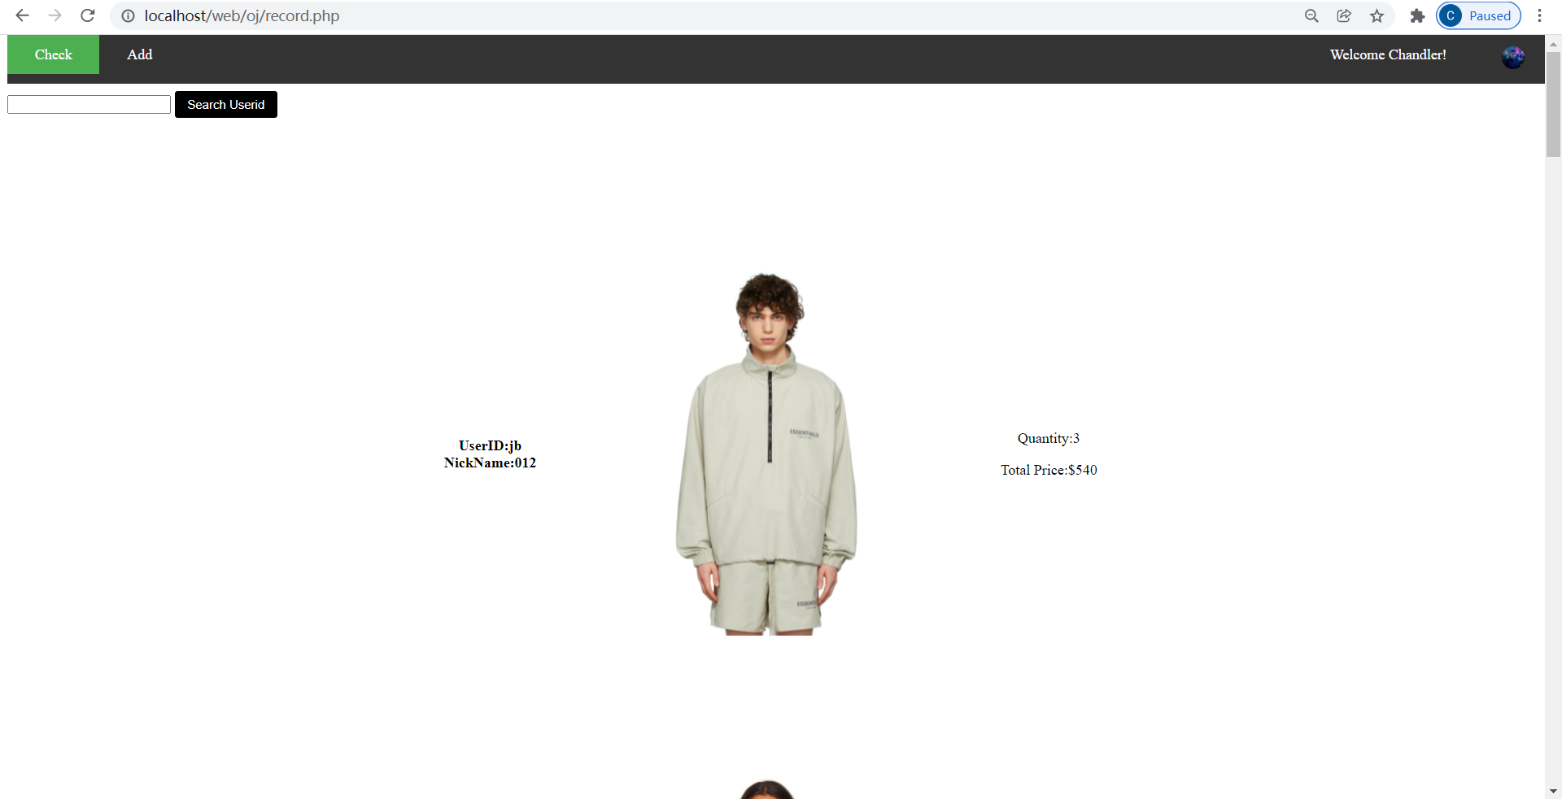

### Chart

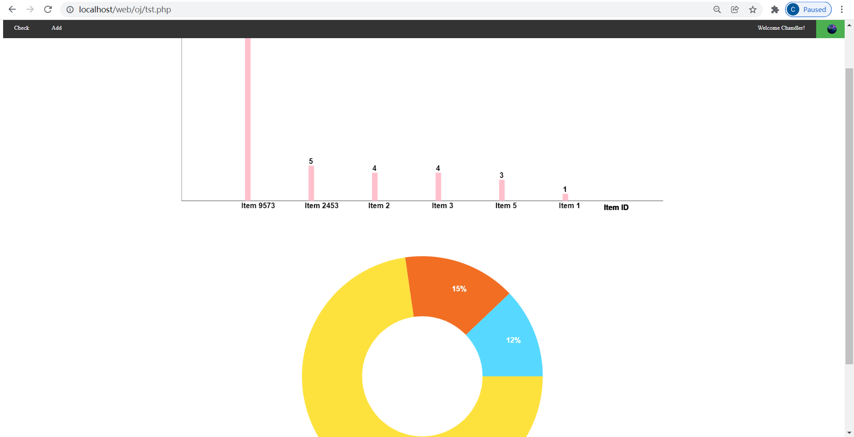

# Conclusion

This project is a comprehensive web design project in which we need to use all the knowledge we have learned on class, and we also need to do a lot of self-studies and find information on the Internet. In the project, I design and build my own database first and do both front-end web development and back-end web development by myself.

It takes a long schedule to finish this project including the last CSS designing. In the whole designing process, I met lots of difficulties. The most serious one is debug problem because I use notepad to write the code. When I met some bug, I can only trace the program by adding some output, for example adding alert(“!”) in JavaScript file. Moreover, there are some browser issues, for example I can not see the CSS file change the web in Google Chrome, but I can see it in IE. After searching the reason online, I find out it is the browser cookies problem that influence the performance of my code.

For me, I think the most precious part in this project is to design the whole logic before start building the database. I need to carefully design every step to make sure the whole system’s stability.

In a word, I think this project is a good survey of the abilities that students have mastered, its value is much higher than the final assessment of any exam format.

# Future Development

This project has fulfilled all the requirement from this subject, but I think there is still a lot of room for improvement.

The first improvement is the php files. There are too many files in the folder, and it will cause a lot of trouble for people want to read the code. I want to encapsulate the php files to reduce the number of them (lots of php files have similar functions). I think maybe I can build a library so that it can be widely use.

The second development is the css files. I just use few css files in my project. Although the UI looks nice to me, there is still a big gap in comparison with professional websites. I want to learn some techniques from them and apply to my own website.

The last development is about the functions. I want to add more categories such as clothes, shoes, hats and so on. I don’t want my website to be restricted in male or female clothes. And for sign up and reset password part. I want to use my website to send a verification email to the user, which not only guarantees the safety of my own webpage, but also the safety of users.